GEF-6 REQUEST FOR PROJECT ENDORSEMENT/APPROVAL
Project Type:
Type of Trust Fund:
For more information about GEF, visit TheGEF.org


part i: project information
Project Title: Reducing Pollution and Preserving Environmental Flows in the East Asian Seas through the Implementation of Integrated River Basin Management in ASEAN Countries
Country(ies)/Executing Agencies: | Cambodia, Indonesia, Lao PDR, Malaysia, Myanmar, Philippines, Vietnam | GEF Project ID: |  | 9654
GEF Agency(ies): | UNDP | GEF Agency Project ID: |  | 5635
Other Executing Partner(s): | PEMSEA Resource Facility  Cambodia: Ministry of Environment  Indonesia: Ministry of Public Works and Housing  Lao PDR: Department of Water Resources Management  Malaysia: Department of Irrigation and Drainage  Myanmar: Department of Environmental Conservation  Philippines: Department of Environment and Natural Resources  Vietnam: Vietnam Environment Agency, Ministry of Natural Resources and Environment | Submission Date: |  | 13 Nov 2018  7 May 2019
GEF Focal Area (s): | International Waters | Project Duration (Months) |  | 60
Integrated Approach Pilot | IAP-Cities IAP-Commodities IAP-Food Security |  | Corporate Program: SGP
Name of Parent Program | Not Applicable | Agency Fee ($) |  | 805,517
- Focal Area Strategy Framework and Other Program Strategies
Focal Area Objectives/Programs | Focal Area Outcomes | Trust Fund | (in $)
Focal Area Objectives/Programs | Focal Area Outcomes | Trust Fund | GEF Project Financing | Co-financing
IW-2 Program 3 | IW Program 3.1: Reduce Nutrient Pollution Causing Ocean Hypoxia |  | 5,079,123 | 51,791,595
IW-2 Program 3 | IW Program 3.2: Addressing the Water/Food/ Energy/Ecosystem Security Nexus |  | 3,400,000 | 70,000,000
Total project costs |  |  | 8,479,123 | 121,791,595

B. Project description summary

Project Objective: To improve governance and management responsiveness and capacities in integrated water resources management, pollution load reduction from nutrients and other land-based activities, protection and conservation of freshwater environmental flows, and alleviation of climate vulnerability through demonstrations, planning, and strengthening of integrated river basin management in selected countries in the East Asian Seas.
Project Component | Financing Type | Project Outcomes | Project Outputs | Trust Fund | (in $)
 |  |  |  |  | GEF Project Financing | Confirmed Co-financing
Component 1: Baseline Assessment of Source to Sea Management Continuum |  | Outcome 1:  Improved understanding of governance, socio-economic and ecological conditions, gaps and needs of priority river basins, sub-basins and coastal areas. | 1.1.1 Bio-physical profiles prepared/ updated covering: a) land uses in the watershed and coastal delta, including significant planned development; b) conjunctive uses of water; c) changes and trends in river water flows and quality over time (including groundwater if available); and d) other biophysical considerations.  1.1.2 Socio-economic and demographic profiles prepared/updated covering existing and forecast growth/development in the respective river basins/sub-basins and coastal areas.  1.1.3 Governance and management systems assessed in each of the selected river basins/sub-basins and corresponding coastal areas, including IRBM and ICM institutional arrangements, policies, legislations/regulations, enforcement, stakeholder participation (including indigenous people, women and the youth), management, scientific and technical capacities, and current levels of financing for source to sea management.  1.1.4 Rapid assessment of land-based pollutant loadings and sources conducted using total pollutant loading models in 7 priority river basins/sub-basins; the impact of existing and planned developments and growth in the river basins assessed in the context of national and local policies and regulations as well as in the context of the corresponding TDAs and SAPs in the various LMEs, particularly with regard to the objectives and/or agreed reductions in nutrient and pollution loads from the rivers into the coastal waters and LMEs where available.  1.1.5: Competing uses and users of water analyzed to assess existing and future water uses and the implications on the applicable water/food/ energy/ecosystem security nexus at the basin/sub-basin level.  1.1.6 Information and knowledge gained from the profiling and modeling activities consolidated into baseline assessments for the 7 priority river basins and coastal areas (State of River Basin (SORB) reports, including existing and forecast conditions, gaps and needs in governance and management; baseline assessments disseminated to national and local governments and other concerned stakeholders in the respective countries for validation, awareness and consensus building. |  | 1,519,302 | 6,800,000
Component 2: IRBM Pilot Projects for Improved Governance and Management of River Basins/Sub-Basins and Associated Coastal Areas | TA | Outcome 2.1:  IRBM pilot projects demonstrate governance mechanisms and instruments for improved source to sea management in 7 priority river basins/sub-basins and coastal areas.  Outcome 2.2: Integrated river basin management strategies and action plans in 7 priority river basins/sub-basins and coastal areas formulated/ updated, adopted and initiated. | 2.1.1 Detailed baseline assessments and feasibility studies conducted at priority hotspot locations in 7 river basins/sub-basins and coastal areas.  2.1.2 Agreements signed and implemented with national agencies, local governments, private sector and other interested partners to finance, construct, operate, assess. and report on IRBM pilot projects in 7 priority river basins/sub-basins and coastal areas in accordance with agreed indicators, monitoring programs, and metrics.  2.2.1 Assessments and recommendations for improved interagency and multisectoral governance structures in priority river basins/sub-basins and coastal areas developed and disseminated.  2.2.2 Assessments and recommendations for improved IRBM policies, laws, financial and economic instruments, and support programs in priority river basins/sub-basins and coastal areas developed and disseminated.  2.2.3 Seven IRBM strategies and action plans endorsed to the appropriate Ministers, Heads of Government Agencies and Authorities, as relevant for each country, for adoption and implementation of the plans. | GETF | 4,359,700 | 102,322,757
Component 3: Knowledge management and learning | TA | Outcome 3.1: Improved IRBM knowledge management and enabling capacities among participating countries, partners and networks. | 3.1.1 Technical report/guide for a harmonized set of IRBM governance and management indicators on inputs, process, socioeconomics, governance, stress reduction, and environmental status, among others, developed, published and disseminated.  3.1.2 Improved IRBM water quality monitoring and reporting programs implemented in connection with IRBM pilot projects in 7 priority river basins/sub-basins and coastal areas.  3.1.3 Core capacities and skills in IRBM development and management transferred to Project Team members, managers and implementers of IRBM projects in 7 priority river basins/sub-basins and coastal areas.  3.1.4 Regional IRBM knowledge and communication management platform operationalized including project M&E reporting.  3.1.5 One percent of the GEF grant allocated for participation in regional and global forums, preparation of experience notes, and organization and conduct of regional twinning activities in collaboration with GEF LME/IW Learn. | GETF | 2,196,998 | 7,700,000
Subtotal |  |  |  |  | 8,076,000 | 116,822,758
Project Management Cost (PMC) |  |  |  | GETF | 403,123 | 4,968,837
Total project costs |  |  |  |  | 8,479,123 | 121,791,595
C. confirmed sources of Co-financing for the project by name and by type
Please include evidence for co-financing for the project with this form.
Sources of Co-financing | Name of Co-financier | Type of Co-financing | Amount ($)
Recipient Governments | Cambodia Ministry of Environment | In-kind | 4,085,337
Recipient Governments | Indonesia Ministry of Public Works and Housing | In-kind | 3,494,667
Recipient Governments | Lao PDR Ministry of Natural Resources and Environment | In-kind | 958,056
Recipient Governments | Malaysia Minstry of Water, Land and Natural Resources | In-kind | 74,000,000
Recipient Governments | Myanmar Ministry of Natural Resource and Environmental Conservation | In-kind | 14,909,000
Recipient Governments | Philippines Department of Environment and Natural Resources | In-kind | 918,123
Recipient Governments | Philippines Department of Environment and Natural Resources | Grant | 5,000,000
Recipient Governments | Vietnam Ministry of Natural Resources and Environment | In-kind | 1,200,000
Beneficiaries | City of Depok (Indonesia) | In-kind | 941,930
Beneficiaries | Province of Loang Namtha (Lao PDR) | In-kind | 217,813
Beneficiaries | Province of Bokeo (Lao PDR) | In-kind | 1,029,363
Beneficiaries | Province of Oudomxay (Lao PDR) | In-kind | 993,050
Beneficiaries | Province of Cavite (Philippines) | In-kind | 389,766
Beneficiaries | City of General Trias (Philippines) | In-kind | 561,000
Beneficiaries | People’s Committee of Da Nang City and Qunag Nam Province (Vietnam) | In-kind | 8,000,000
Others | UNDP | In-kind | 197,403
Others | JICA Vietnam | In-kind | 4,600,000
Others | PEMSEA | In-kind | 296,087
Total Co-financing |  |  | 121,791,595
D. Trust Fund Resources Requested by Agency(ies), Country(ies) and the Programming of Funds
GEF Agency | Trust Fund | Country  Name/Global | Focal Area | Programming of Funds | (in $)
 |  |  |  |  | GEF Project Financing (a) | Agency Fee  (b) | Total  (c)=a+b
 |  | Regional  (Cambodia, Indonesia, Lao PDR, Myanmar, Malaysia, Philippines, Vietnam) |  |  | 8,479,123 | 805,517 | 9,284,640
Total Grant Resources |  |  |  |  | 8,479,123 | 805,517 | 9,284,640

E. Project’s Target Contributions to Global Environmental Benefits

Corporate Results | Replenishment Targets | Project Targets
3. Promotion of collective management of transboundary water systems and implementation of the full range of policy, legal, and institutional reforms and investments contributing to sustainable use and maintenance of ecosystem services. | Water-food-ecosystems security and conjunctive management of surface and groundwater in at least 10 freshwater basins; | 7 freshwater basins
F. Project Taxonomy
Please update the table below for the taxonomic information provided at PIF stage. Use the GEF Taxonomy Worksheet provided in Annex G to find the most relevant keywords/topics/themes that best describe the project.
Level 1 | Level 2 | Level 3 | Level 4
Influencing models
 | Transform policy and regulatory environments
 | Strengthen institutional capacity and decision-making
 | Convene multi-stakeholder alliances
 | Demonstrate innovative approaches
 | Deploy innovative financial instruments
Stakeholders
 | Indigenous Peoples
 | Private Sector
 |  | Capital providers
 |  | Financial intermediaries and market facilitators
 |  | Large corporations
 |  | SMEs
 |  | Individuals/Entrepreneurs
 |  | Non-Grant Pilot
 |  | Project Reflow
 | Beneficiaries
 | Local Communities
 | Civil Society
 |  | Community Based Organization
 |  | Non-Governmental Organization
 |  | Academia
 |  | Trade Unions and Workers Unions
 | Type of Engagement
 |  | Information Dissemination
 |  | Partnership
 |  | Consultation
 |  | Participation
 | Communications
 |  | Awareness Raising
 |  | Education
 |  | Public Campaigns
 |  | Behavior Change
Capacity, Knowledge and Research
 | Enabling Activities
 | Capacity Development
 | Knowledge Generation and Exchange
 | Targeted Research
 | Learning
 |  | Theory of Change
 |  | Adaptive Management
 |  | Indicators to Measure Change
 | Innovation
 | Knowledge and Learning
 |  | Knowledge Management
 |  | Innovation
 |  | Capacity Development
 |  | Learning
 | Stakeholder Engagement Plan
Gender Equality
 | Gender Mainstreaming
 |  | Beneficiaries
 |  | Women groups
 |  | Sex-disaggregated indicators
 |  | Gender-sensitive indicators
 | Gender results areas
 |  | Access and control over natural resources
 |  | Participation and leadership
 |  | Access to benefits and services
 |  | Capacity development
 |  | Awareness raising
 |  | Knowledge generation
Focal Areas/Theme
 | Integrated Programs
 |  | Commodity Supply Chains (Good Growth Partnership)
 |  |  | Sustainable Commodities Production
 |  |  | Deforestation-free Sourcing
 |  |  | Financial Screening Tools
 |  |  | High Conservation Value Forests
 |  |  | High Carbon Stocks Forests
 |  |  | Soybean Supply Chain
 |  |  | Oil Palm Supply Chain
 |  |  | Beef Supply Chain
 |  |  | Smallholder Farmers
 |  |  | Adaptive Management
 |  | Food Security in Sub-Sahara Africa
 |  |  | Resilience (climate and shocks)
 |  |  | Sustainable Production Systems
 |  |  | Agroecosystems
 |  |  | Land and Soil Health
 |  |  | Diversified Farming
 |  |  | Integrated Land and Water Management
 |  |  | Smallholder Farming
 |  |  | Small and Medium Enterprises
 |  |  | Crop Genetic Diversity
 |  |  | Food Value Chains
 |  |  | Gender Dimensions
 |  |  | Multi-stakeholder Platforms
 |  | Food Systems, Land Use and Restoration
 |  |  | Sustainable Food Systems
 |  |  | Landscape Restoration
 |  |  | Sustainable Commodity Production
 |  |  | Comprehensive Land Use Planning
 |  |  | Integrated Landscapes
 |  |  | Food Value Chains
 |  |  | Deforestation-free Sourcing
 |  |  | Smallholder Farmers
 |  | Sustainable Cities
 |  |  | Integrated urban planning
 |  |  | Urban sustainability framework
 |  |  | Transport and Mobility
 |  |  | Buildings
 |  |  | Municipal waste management
 |  |  | Green space
 |  |  | Urban Biodiversity
 |  |  | Urban Food Systems
 |  |  | Energy efficiency
 |  |  | Municipal Financing
 |  |  | Global Platform for Sustainable Cities
 |  |  | Urban Resilience
 | Biodiversity
 |  | Protected Areas and Landscapes
 |  |  | Terrestrial Protected Areas
 |  |  | Coastal and Marine Protected Areas
 |  |  | Productive Landscapes
 |  |  | Productive Seascapes
 |  |  | Community Based Natural Resource Management
 |  | Mainstreaming
 |  |  | Extractive Industries (oil, gas, mining)
 |  |  | Forestry (Including HCVF and REDD+)
 |  |  | Tourism
 |  |  | Agriculture & agrobiodiversity
 |  |  | Fisheries
 |  |  | Infrastructure
 |  |  | Certification (National Standards)
 |  |  | Certification (International Standards)
 |  | Species
 |  |  | Illegal Wildlife Trade
 |  |  | Threatened Species
 |  |  | Wildlife for Sustainable Development
 |  |  | Crop Wild Relatives
 |  |  | Plant Genetic Resources
 |  |  | Animal Genetic Resources
 |  |  | Livestock Wild Relatives
 |  |  | Invasive Alien Species (IAS)
 |  | Biomes
 |  |  | Mangroves
 |  |  | Coral Reefs
 |  |  | Sea Grasses
 |  |  | Wetlands
 |  |  | Rivers
 |  |  | Lakes
 |  |  | Tropical Rain Forests
 |  |  | Tropical Dry Forests
 |  |  | Temperate Forests
 |  |  | Grasslands
 |  |  | Paramo
 |  |  | Desert
 |  | Financial and Accounting
 |  |  | Payment for Ecosystem Services
 |  |  | Natural Capital Assessment and Accounting
 |  |  | Conservation Trust Funds
 |  |  | Conservation Finance
 |  | Supplementary Protocol to the CBD
 |  |  | Biosafety
 |  |  | Access to Genetic Resources Benefit Sharing
 | Forests
 |  | Forest and Landscape Restoration
 |  |  | REDD/REDD+
 |  | Forest
 |  |  | Amazon
 |  |  | Congo
 |  |  | Drylands
 | Land Degradation
 |  | Sustainable Land Management
 |  |  | Restoration and Rehabilitation of Degraded Lands
 |  |  | Ecosystem Approach
 |  |  | Integrated and Cross-sectoral approach
 |  |  | Community-Based NRM
 |  |  | Sustainable Livelihoods
 |  |  | Income Generating Activities
 |  |  | Sustainable Agriculture
 |  |  | Sustainable Pasture Management
 |  |  | Sustainable Forest/Woodland Management
 |  |  | Improved Soil and Water Management Techniques
 |  |  | Sustainable Fire Management
 |  |  | Drought Mitigation/Early Warning
 |  | Land Degradation Neutrality
 |  |  | Land Productivity
 |  |  | Land Cover and Land cover change
 |  |  | Carbon stocks above or below ground
 |  | Food Security
 | International Waters
 |  | Ship
 |  | Coastal
 |  | Freshwater
 |  |  | Aquifer
 |  |  | River Basin
 |  |  | Lake Basin
 |  | Learning
 |  | Fisheries
 |  | Persistent toxic substances
 |  | SIDS : Small Island Dev States
 |  | Targeted Research
 |  | Pollution
 |  |  | Persistent toxic substances
 |  |  | Plastics
 |  |  | Nutrient pollution from all sectors except wastewater
 |  |  | Nutrient pollution from Wastewater
 |  | Transboundary Diagnostic Analysis and Strategic Action Plan preparation
 |  | Strategic Action Plan Implementation
 |  | Areas Beyond National Jurisdiction
 |  | Large Marine Ecosystems
 |  | Private Sector
 |  | Aquaculture
 |  | Marine Protected Area
 |  | Biomes
 |  |  | Mangrove
 |  |  | Coral Reefs
 |  |  | Seagrasses
 |  |  | Polar Ecosystems
 |  |  | Constructed Wetlands
 | Chemicals and Waste
 |  | Mercury
 |  | Artisanal and Scale Gold Mining
 |  | Coal Fired Power Plants
 |  | Coal Fired Industrial Boilers
 |  | Cement
 |  | Non-Ferrous Metals Production
 |  | Ozone
 |  | Persistent Organic Pollutants
 |  | Unintentional Persistent Organic Pollutants
 |  | Sound Management of chemicals and Waste
 |  | Waste Management
 |  |  | Hazardous Waste Management
 |  |  | Industrial Waste
 |  |  | e-Waste
 |  | Emissions
 |  | Disposal
 |  | New Persistent Organic Pollutants
 |  | Polychlorinated Biphenyls
 |  | Plastics
 |  | Eco-Efficiency
 |  | Pesticides
 |  | DDT - Vector Management
 |  | DDT - Other
 |  | Industrial Emissions
 |  | Open Burning
 |  | Best Available Technology / Best Environmental Practices
 |  | Green Chemistry
 | Climate Change
 |  | Climate Change Adaptation
 |  |  | Climate Finance
 |  |  | Least Developed Countries
 |  |  | Small Island Developing States
 |  |  | Disaster Risk Management
 |  |  | Sea-level rise
 |  |  | Climate Resilience
 |  |  | Climate information
 |  |  | Ecosystem-based Adaptation
 |  |  | Adaptation Tech Transfer
 |  |  | National Adaptation Programme of Action
 |  |  | National Adaptation Plan
 |  |  | Mainstreaming Adaptation
 |  |  | Private Sector
 |  |  | Innovation
 |  |  | Complementarity
 |  |  | Community-based Adaptation
 |  |  | Livelihoods
 |  | Climate Change Mitigation
 |  |  | Agriculture, Forestry, and other Land Use
 |  |  | Energy Efficiency
 |  |  | Sustainable Urban Systems and Transport
 |  |  | Technology Transfer
 |  |  | Renewable Energy
 |  |  | Financing
 |  |  | Enabling Activities
 |  | Technology Transfer
 |  |  | Poznan Strategic Programme on Technology Transfer
 |  |  | Climate Technology Centre & Network (CTCN)
 |  |  | Endogenous technology
 |  |  | Technology Needs Assessment
 |  |  | Adaptation Tech Transfer
 |  | United Nations Framework on Climate Change
 |  |  | Nationally Determined Contribution
 |  |  | Paris Agreement
 |  |  | Sustainable Development Goals
 |  | Climate Finance (Rio Markers)
 |  |  | Climate Change Mitigation 1
 |  |  | Climate Change Mitigation 2
 |  |  | Climate Change Adaptation 1
 |  |  | Climate Change Adaptation 2

part ii: project justification

A. describe any changes in alignment with the project design with the original pif
A.1. Project Description. Elaborate on: 1) the global environmental and/or adaptation problems, root causes and barriers that need to be addressed; 2) the baseline scenario or any associated baseline projects, 3) the proposed alternative scenario, GEF focal area strategies, with a brief description of expected outcomes and components of the project, 4) incremental/additional cost reasoning and expected contributions from the baseline, the GEFTF, LDCF, SCCF, and co-financing; 5) global environmental benefits (GEFTF) and/or adaptation benefits (LDCF/SCCF); and 6) innovativeness, sustainability and potential for scaling up.

Change in Number of Participating Countries: The number of countries participating in the project has been reduced from 8 to 7. Thailand was unable to sign the PIF.

Baseline Scenario: Change in National River Basins as Potential Sites for the IRBM Project
During the PPG Inception Workshop (August 2017), the 7 participating countries developed and agreed to criteria for the selection of river basins for the IRBM project. The criteria and final list of selected priority river basins may be found in Table 1. Upon applying the selection criteria, four of the seven participating countries changed the river basins/sub-basins from those identified in the PIF (i.e., Indonesia, Myanmar, Philippines, and Vietnam). Information on the analysis and selection of river basins within each country is summarized in the National IRBM Project Proposals (Annex K of the Project Document), including identification of ongoing and planned initiatives (governance, management, scientific, investment) in each river basin that will serve as a foundation for the IRBM project.

Table 1: Country Selection of Priority River Basins

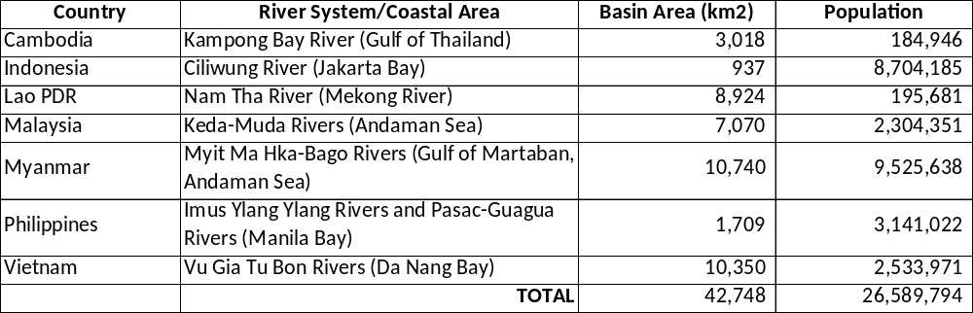

Change in Outputs: Based on inputs from government and non-government stakeholders in the 7 participating countries, as well as the downsizing of the project budget from $11.5 million to $8.47 million, the outputs in Component 2 have been modified. The project has adopted a four-tiered approach to planning, development and implementation, namely regional, national, river basin, and pilot project tiers. Output 2.1.1 focuses on the pilot project tier, and involves developing and implementing an IRBM pilot project at an identified hotspot location in each river basin. The pilot projects will focus on priority issues within the river basins, and will serve as hands-on learning experiences for improved IRBM governance and management, from which to build and up-scale IRBM to the river basin/sub-basin tier. Outputs 2.2.1 and 2.2.2 relate to the river basin/sub-basin tier and are about reviewing and assessing options for improving: a) governance and institutional mechanisms; and b) IRBM policies, laws, financial and economic instruments, and support programs in the priority river basins based on the pilot project expereince. Output 2.2.3 involves developing, building consensus, adopting and initiating IRBM strategies and action plans in the 7 priority river basins. The IRBM strategies and action plans will incorporate action agenda that were identified in the Outputs 2.2.1 and 2.2.2, as modified and agreed to through a public consultation process, in addition to: inputs from SORB reports (Outcome 1); good practices and lessons from pilot projects; and the development goals and objectives of river basin organizations, local governments, communities and social and economic sectors in the river basin and coastal region. The strategies and action plans will be submitted to the respective national government authorities and signatories for adoption, financing/budget allocation, and initiation.

As indicated in Output 2.2.3, initiation of adopted river basin strategies and action plans will specifically target commitments of adequate human and financial resources to scale-up or replicate at least one priority management intervention in each river basin.

In response to the comments received from STAP on Component 3 (Knowledge Management, Capacity Development and Moniotirng and Evaluation) a single outcome was identified for the Component, namely "Improved IRBM knowledge management/sharing and enabling capacities among participating countries, partners and networks." The outcomes previously identified in the PIF were transformed into 5 outputs, as follows:
- Output 3.1.1: Technical report/guide for a harmonized set of IRBM governance and management indicators on inputs, process, socioeconomics, governance, stress reduction, and environmental status, among others, developed, published and disseminated.
- Output 3.1.2: Improved IRBM water quality monitoring and reporting programs implemented in connection with IRBM pilot projects in 7 priority river basins/sub-basins and coastal areas.
- Output 3.1.3: Core capacities and skills in IRBM development and management transferred to Project Team members, managers and implementers of IRBM projects in 7 priority river basins/sub-basins and coastal areas.
- Output 3.1.4: Regional IRBM knowledge and communication management platform operationalized including project M&E reporting.
- Output 3.1.5: One percent of the GEF grant allocated to participation in regional and global forums, preparation of experience notes, and organization and conduct of regional twinning activities in collaboration with GEF LME/IW Learn.

Innovativeness and Sustainability and Potential for Scaling up: During the preparatory phase, it became quite apparent that participating countries were being challenged with the transition from an IWRM governance and planning mode to a functional IRBM management program. For the project to assist with this transition, it was agreed that each river basin initiative would include a "pilot project" to provide countries with a hands-on learning experience in tackling (a) priority challenge(s) to IRBM (Table 2). In this way, the pilot project would serve as a learning site and show place in the river basin/country during project implementation, and a knowledge base for up-scaling and replication beyond the life of the project.

It was further recognized by countries that the capital financing for the planned pilot projects was beyond the available budget of the GEF-supported IRBM project. Thus, one of the major challenges the IRBM project will be to put in place the partnerships and financings for the pilot projects. This, in fact, is the major stumbling block currently faced by local governments and river basin organizations. By walking local governments and river basin organizations through the process of project development, financing and sustainable implementation, a legacy of approaches, experiences and networking will be created. In particular, the project will facilitate the development, assessment and operationalization of financing options (e.g., public, public-private, private) and partnership arrangements. One innovative financing option that will be explored is referred to as a “PPP Inclusive Growth Fund”. This option will assess opportunities for an effective and equitable financing structure that facilitates pro-active participation of the private sector, the government and the community in the financing, ownership and operation of the pilot project.

Table 2: IRBM Pilot Sites and Priorty Issues

River Basin/Country | Pilot Project Sites | Priority Issues at the Pilot Sites
- Kampong Bay River Basin, Cambodia | Kampot City | Pollution reduction/nutrient management; water resource management (i.e., environmental flows from upstream hydroelectric dam operation and saltwater intrusion); seasonal flooding; protection and conservation of natural resources; reforestation
- Ciliwung River Basin, Indonesia | Depok City | Pollution reduction/nutrient management; solid waste management
- Nam Tha River Basin,  Lao PDR | Loungnamtha Town Proper | Reforestation and sustainable management of forests; pollution reduction/nutrient management
- Kedah River Basin,  Malaysia | Alor Setar City | Pollution reduction/nutrient management; water resource management (i.e., environmental flows from upstream hydroelectric dam operation and agricultural irrigation)
- Myit Ma Hka-Bago River Basin, Myanmar | Bago City | Solid waste management; water resource management/water security (i.e., flooding and drought conditions)
- Imus-Ylang Ylang and Pasac-Guagua River Basins,  Philippines | General Trias City  Guagua Municipality | Pollution reduction/nutrient management; solid waste management; water resource management (environmental flows; sustainable water supply)  Water resource management (environmental flows; sustainable water supply for domestic, agricultural and aquacultural purposes)
- Vu Gia Thu Bon River Basin, Vietnam | Quang Nam Province and  Da Nang City | Pollution reduction/nutrient management; solid waste management; water resource management (environmental flows for salt water intrusion; hydroelectric dam operation; sustainable water use/security for domestic, agriculture and aquaculture purposes)

A.2. Child Project? If this is a child project under a program, describe how the components contribute to the overall program impact.

NA

A.3. Stakeholders. Identify key stakeholders and elaborate on how the key stakeholders engagement is incorporated in the preparation and implementation of the project. Do they include civil society organizations (yes)? and indigenous peoples (yes)?
Annex F of the Project Document (page 125) provides a comprehensive analysis of key stakeholders at the regional, national and local levels in the priority river basins and coastal areas in the 7 countries. During project implementation, stakeholders will be engaged in a highly participatory and inclusive manner, including consultations relating to:
- The identification and prioritization of demonstration and replication sites in the priority river basins;
- Baseline assessments and the development of State of River Basin Reports covering physical, chemical, biological aspects of environmental flows, as well as socio-economic, demographic and governance and management conditions in the river basins and coastal regions;
- Capacity needs and gap analysis of stakeholders in IRBM;
- Governance system analysis for the sustainable management of the priority river basins with linkages to national, regional and global priorities, targets and commitments including the SDGs, climate change, biodiversity conservation, pollution reduction, and waste management;
- Gender inequities relating to water resources management;
- Broader social inclusion at the community level in relation to decision-making around the use of water resources;
- National consultations relating to planning, activity design, setting of targets/indicators, monitoring and evaluation, and consolidation of outputs, among other things; and
- Scaling up and replication of good practices in IRBM at the river basin and national levels.

The IRBM project focuses on improving environmental flows, reducing pollution and enhancing climate resiliency by strenthening management mechanisms, planning and decision-making. The project is also aimed to improving linkages with industry, civil society including private sector and NGOs and communities as well as development partners. Continued consultations with stakeholder groups throughout project design and implementation stages are also important. In support of effective communication among stakeholders at the river basin, natinal and regional levels, the Regional Project Management Unit will establish an IRBM portal to serve as knowledge sharing platform and information depository for the project.

A.4. Gender Equality and Women's Empowerment. Elaborate on how gender equality and women’s empowerment issues are mainstreamed into the project implementation and monitoring, taking into account the differences, needs, roles and priorities of women and men. In addition, 1) did the project conduct a gender analysis during project preparation (yes /no)?; 2) did the project incorporate a gender responsive project results framework, including sex-disaggregated indicators (yes /no)?; and 3) what is the share of women and men direct beneficiaries (women 50%, men 50%)?

To advance women’s equal participation with men as decision makers in the IRBM project work, a gender action plan (GAP) was developed during the project preparation phase based on desk top research as well as the gender analysis in each of the river basins. Apart from the equitable representation of women in all aspects of project processes, meetings and activities, the GAP also seeks to promote gender mainstreaming in all project components, implementation of project activities and at all stakeholder levels. The IRBM project requires that project attention to gender perspectives is explicit and integrates gender-responsive budgeting into IRBM finance.

The GAP includes gender-related activities for all river basins to promote and facilitate gender balance, women’s participation and leadership, as well as special actions which systematically support women’s skills, livelihood development, and engagement in river basin management. Activities vary in terms of measurability, project effort and scope. Some activities will be supported by organizations that are already involved in related development work in the river basins or have local know how. The designed gender actions are not static, they will be completed and adapted with the ongoing project and the individual requirements of the hotspots.
The following recommendations for all project components and countries are made to promote opportunities, drivers of change and positive gender dynamics as well as to manage and mitigate potential adverse risks over the duration of the project:
- The presence of gender equality goals, outcomes and outputs are reflected in each project component and women will be represented in all aspects of the project work;
- Indicators and monitoring targets are set in terms of the gender objectives of reducing gender gaps, including gender-disaggregated monitoring indicators;
- Support and control mechanisms, such as gender focal points in each river basin are defined;
- Expenditures for gender-balanced capacity building and activities are allocated in each component and calculated in the project budget; and
- Participatory monitoring and evaluation processes are captured, reflecting gender beneficiaries and monitoring improvement for women’s welfare and status.

The following directives have been identified for specific gender actions listed in the GAP to complement the IRBM approach to the components:
- Implementation of women-specific livelihood activities and associated benefits (e.g., livelihoods along the recycling systems);
- Skills development (e.g. IRBM/ICM management; sewerage treatment; solid waste management/recycling; reforestation);
- Strengthening of women’s involvement in planning and decision-making at national and subnational levels (e.g., equal participation; strengthening women`s empowerment); and
- Participation of women as agents of economic, social and political change at the community level (e.g. waste awareness; waste reduction/segregation; sanitation).

A.5 Risk. Elaborate on indicated risks, including climate change, potential social and environmental risks that might prevent the project objectives from being achieved, and, if possible, the proposed measures that address these risks at the time of project implementation.(table format acceptable):

1. Environmental risks: Impacts of pollution, land development, conflicting water uses and climate change in the selected river basins undermine the sustainability of S2S/ IRBM management, by adversely impacting environmental flows and biological processes that underpin provisioning, regulating and supporting ecosystem services.

To mitigate these environmental risks, which vary in scope and severity across the river basins, substantial project resources are devoted to toward increasing capacities, experience and knowledge base in each river basin regarding the reduction and mitigation of impacts on environmental flows and the water/food/energy/ecosystem security nexus, and the associated consequences on local communities. The increased capabilities, experience and supporting networks resulting from these efforts will facilitate improvements in governance and management of the selected river basins as well as better informed strategies for scaling up and replicating good IRBM practices within and across priority river basins.

2. Political risk: Lack of national and local political support and buy-in for implementation of IRBM. To help overcome this risk, the selection of priority river basins and coastal areas for the project involved national and local governments, NGOs and scientific institutions in each country. This established ownership for the project at the two levels of government. During project development and implementation, the project will work from the bottom-up, working closely with local Chief Executives and decision-makers at hotspot locations within river basins/sub-basins, to provide on-the-ground solutions to hotspot issues. One of the criteria used in selecting a hotspot location for a pilot project is evidence of political will and commitment to invest in the project and to allocate the necessary resources to sustain the IRBM program. Lessons learned and good practices will then be shared and transferred to national levels for adaptation and use in national IRBM policy and programming.

3. Political risk: Change in key policy and/or decision makers or other events beyond the control of the project lead to changes in priorities and/or support for the project. A 5-year long project will inevitably operate across national and subnational election cycles. To help address this, the project is designed to facilitate national responses to agreed regional action programs, including the ASEAN, SDS-SEA, SCS LME, BOB LME, CTI-CFF, etc., which are long-term commitments that are mostly unaffected by changes in national or local governments.

4. Regulatory risk: Enabling decisions required for implementation of some of the key project activities may be delayed due to inefficiencies and/or lack of ownership by national and/or local government units. A number of the planned project activities require high level, intergovernmental and multi-sectoral enabling decisions including commitments to resource access and use, approval of river basin governance systems, strategies and action plans, and investment in action plan implementation. Existing and planned River Basin Coordinating Committees are critical to this process, with membership from key national agencies, local governments with jurisdiction in the river basin and coastal areas, as well as community groups, universities/scientific and technical insitutions and the business sector. The project will provide hands-on experience in planning, consultation, negotiation, conflict resolution, etc. in developing and investing in pilot projects, and forging longer-term actions to help overcome conflicts and to build mulit-sectoral ownership and commitment to concrete solutions.

5. Strategic risks: Complex water and land use policy and practice in river basins will impede adoption of integrated management approaches. Given the nature of the proposed project – oriented toward joint fact finding, consensus building, establishing processes, creating enabling political environments, it is envisaged that this participatory, multi-sectoral approach will promote greater awareness and recognition of the benefits and impacts of sustainable upstream land use and water resource management practices, integrated with sustainable downstream coastal water resources management on the communities, individuals and economies of the river basins and coastal areas.

A.6. Institutional Arrangement and Coordination. Describe the institutional arrangement for project implementation. Elaborate on the planned coordination with other relevant GEF-financed projects and other initiatives.

The project institutional arrangements entail a 4-tier approach:
- A regional tier, being the Project Board/Steering Committee, namely the ASEAN Working Group for Water Resources Management, will review and assess the performance of the project, appraise annual work plans and budgets, and facilitate knowledge sharing and opportunities for up-scaling IRBM project results and lessons learned to relevant audiences in ASEAN as well as country-based projects. UNDP will serve as co-Chair of the Project Board, while PEMSEA will serve as secretariat.
- A national tier will facilitate cooperation and involvement of national agencies in planning and coordination, advisory, and knowledge sharing processes, as well as reviewing and assessing outputs in the context of contributions to national policies and programs. The national tier will have representation/ participation in the activities at the river basin and pilot project levels (see below). National agency representatives will use the experience to catalyze the development or improvement of national IRBM policies, institutional mechanisms, laws, etc., thereby mainstreaming IRBM environmental sustainability into programs and investments at the national level. The national tier ensures cooperation and involvement of central agencies in the planning and coordination of central agency support and advisory processes to the project. Existing coordinating mechanisms will be employed, with National Implementing Partners taking the lead in coordinating input to the project. It is also at this level that linkages to and synergies with the respective LME SAPs and corresponding national action plans will be facilitated through the existing national LME coordinating/implementing mechanisms.
- A river basin tier will be responsible for the planning, coordination, management and monitoring and evaluation of the project at the river basin level, within existing river basin organizations or interim mechanisms set up during the project. The river basin tier will be comprised of representatives from responsible national agencies, local governments, non-governmental organizations, business community/private sector and other major stakeholders in the river basin. The river basin tier will use the outputs of the project, including the tools, networks and skills generated during the project, to develop, adopt and initiate river basin strategies and 10-year action plans aimed at scaling-up and replicating good practices and lessons learned in water use/conservation, pollution reduction/waste management; sustainable reforestation, etc. The river basin tier serves as the main platform for bottom up and top down engagement, via existing river basin coordinating mechanisms in 4 of the selected river basins (Indonesia, Philippines, Malaysia, Vietnam) or via interim coordinating mechanisms set up by the project in Cambodia, Lao PDR, and Myanmar. The river basin coordinating mechanisms include representation from national and local governments, NGOs, indigenous peoples (where present), business community/private sector, and local communities in the respective basins.
- A pilot project tier will be involved in the development, implementation, monitoring and reporting of solution- and impact-oriented IRBM demonstration projects at a hotspot location in each river basin. The IRBM pilot projects will focus on governance and management priorities such as water quality improvement, pollution reduction, waste management, reforestation, and water use and conservation management at the local level. The local tier Project Teams will be capacitated through formal training and working with technical experts and professionals contracted by the project, to develop, implement and demonstrate IRBM templates that result in real-life changes at the local scale. By the end of the project, the local tier Project Teams will be enabled to use proven tools and their experience to promote and facilitate scaling up and replicating good practices and lessons to the river basin tier. The pilot sites will serve as showcases and learning centers for IRBM governance and management, which will provide real impact in the local areas while also creating knowledge, capacity development and scaling-up/replication opportunities for the river basins.

PEMSEA will serve as Executing Agency for the project and UNDP will provide technical and financial oversight.

Additional Information not well elaborated at PIF Stage:

A.7 Benefits. Describe the socioeconomic benefits to be delivered by the project at the national and local levels. How do these benefits translate in supporting the achievement of global environment benefits (GEF Trust Fund) or adaptation benefits (LDCF/SCCF)?

The global environmental benefits generated by the project will be underpinned by socio-economic benefits including: sustainable, alternative non-ecosystem-based livelihoods; pollution reduction/nutrient management and improved water quality and water security; and wastewater management, all accruing from improved IRBM. Socio-economic benefits that are measurable within the duration of the project will occur primarily at the river basin level and at "hotspot sites" that serve as pilot project locations. In addition, the awareness raising, knowledge sharing and the skills development aspects of the project will better enable local governments and communities with the tools and know-how to protect, manage and use their rivers and marine waters and the natural resources therein in a sustainable manner.

The ultimate success of implementation of the IRBM project will be measured by how priority actions are carried out and replicated at the local level, and the socio-economic and environmental benefits derived. Providing scale-able frameworks, e.g., through IRBM plans, tools and templates, will provide river basin organizations, local governments and communities with a roadmap for integrating the socio-economic development priorities of their river basin and coastal communities with the conservation and sustainable management of the ecosystem goods and services of the area.

Project components were designed with the full acknowledgment of the human reource capacity at the country levels and within the river basins and coastal communities. Sufficient time and budgets have been allocated to each project component in order to allow for ‘socialization’ of the project engagement and gender targets. For example, improved IRBM management will result in more equitable access for women and vulnerable groups to planning and decision-making processes, employment, and safer, accessible water supplies. The number of direct project beneficiaries will be identified during the detailed baseline assessment and socio-economic surveys conducted during project start-up. The total population across the selected 7 river basins and coastal areas is 26,589,794, representing direct environmental beneficiaries of the IRBM project.

A.8 Knowledge Management. Elaborate on the knowledge management approach for the project, including, if any, plans for the project to learn from other relevant projects and initiatives (e.g. participate in trainings, conferences, stakeholder exchanges, virtual networks, project twinning) and plans for the project to assess and document in a user-friendly form (e.g. lessons learned briefs, engaging websites, guidebooks based on experience) and share these experiences and expertise (e.g. participate in community of practices, organize seminars, trainings and conferences) with relevant stakeholders.

Governance and management challenges among the river basins in the 7 countries are not dissimilar, covering: water pollution (organic, nutrients, toxic and hazardous waste); solid waste; deforestation; biodiversity loss; erosion, siltation, flooding and landslides; water security/water quality (drinking water; recreation; aquaculture); competing uses (dams; irrigation; urbanization, domestic and industrial use); and climate change. It is not possible to address all of these challenges, even for one river basin, in this foundational project. The approach of the project is to demonstrate sustainable IRBM solution templates at pilot scale for improved governance, pollution, waste management, deforestation, and water use conflicts, as a starting point to wider change. The application of the template solutions under disparate conditions (i.e., political, legal, social, economic and environmental), provides greater opportunity for replication and up-scaling, recognizing that such differences are not only present among countries of the region, but also within and across river basins/ sub-basins of the countries themselves.

At the regional level, the project will focus on developing and transferring tools, templates, and enabling capacities to the national and local river basin organizations, managers and project teams, and providing access to a team of IRBM scientific and technical, financial and investment, legal, and socio-economic professionals/specialists to adapt and apply these tools to solve real governance and management issues under local conditions. The regional level activities will also concentrate on monitoring and evaluation of progress, outputs and outcomes, sharing of experiences, lessons and good practices via ASEAN, PEMSEA and other regional organizations and networks, the development and transfer of knowledge products based on the experiences in the river basins, building/ strengthening scientific, technical and financing and investment support networks, and operationalizing an e-knowledge platform to link and promote cooperation among IRBM communities within countries of the region, and with other regions. The regional aspects of the project are included in all three components of the project.

At the country level, the existing and interim river basin organizations and project teams will: prepare a baseline State of River Basin Report for each river basin (Component 1) including priorities, gaps and needs for improved IRBM governance and management; plan, develop and implement pilot projects at hot spot locations in each river basin as learning sites/showcases for sustainable IRBM management, financing and investment, (Component 2) including opportunities for scaling up and replicating improved governance and management in the selected river basin based on the experience of the pilot projects; and packaging and transferring experiences, lessons and good practices to other river basins within their country and among participating countries in the regional project (Component 3).

The experiences, lessons, good practices and recommendations coming from the project will benefit all participating countries. Generic tools, processes, and templates for improved IRBM governance and management will be adapted, tested and demonstrated under a variety of political and legal regimes, environmental conditions, economic systems, demographic and social profiles, as well as capacities. This is the advantage of the project, as adaptive management is a critical feature of all IRBM programs. The project does not propose immediate change for all issues across all river basins/coastal areas, but does target full change and solutions for selected hotspot areas (i.e., pilot sites) and key issues (i.e., nutrient reduction; wastewater management; water management) to initiate change at larger scales through knowledge and experience sharing.

B. DESCRIPTION OF THE CONSISTENCY OF THE PROJECT WITH:

B.1 Consistency with National Priorities. Describe the consistency of the project with national strategies and plans or reports and assessments under relevant conventions such as NAPAs, NAPs, ASGM NAPs, MIAs, NBSAPs, NCs, TNAs, NCSAs, NIPs, PRSPs, NPFE, BURs, INDCs, etc.:

A number of initiatives have already been undertaken at the regional and country levels, particularly related to SDG targets 6.5 and 6.6 (i.e., implement IWRM at all levels; and protect and restore forests, wetlands, rivers, etc.) and targets 14.1 and 14.2 (i.e., prevent and reduce marine pollution; and sustainably management and protect marine and coastal ecosystems). For example, the ASEAN Long Term Strategic Plan of Action for Water Resources Management was endorsed by the ASEAN Member State Environment Ministers in 2002. The vision for water in Southeast Asia by 2025 is: “the attainment of sustainability of water resources to ensure sufficient water quantity of acceptable quality to meet the needs of the people of Southeast Asia in terms of health, food security, economy and environment.” To ensure that concrete actions were undertaken, the ASEAN Socio-Cultural Community (ASCC) adopted “Blueprint 2009-2015”, which outlined a set of actions to fulfill the Strategic Objectives related to water resources management. Among others, the actions included promoting the implementation of integrated river basin management (IRBM), strengthening public awareness and partnerships to enhance integrated water resources management (IWRM), and improving regional cooperation on water conservation measures and programs as well as scientific and technological innovations in water quality improvement and supply. With respect to the coastal area and in recognition of the region’s 173,000 km of coastline, the same Blueprint committed to “ensure ASEAN’s coastal and marine environment are sustainably managed …” and “…promote cooperation in addressing pollution of coastal and marine environment from land-based sources.”

At the national level, a number of the ASEAN Member States have adopted water-related/IWRM policy and practices at national and basin levels (Table 2). Whereas some countries, notably Indonesia, Lao PDR, Malaysia, the Philippines, and Vietnam have made progress by putting in place governance mechanisms in priority river basins and developing and adopting multi-year action plans, operationalizing these mechanisms and action plans have faced difficulties. Barriers for effective national implementation are multiple including: a) coordination and cooperation between national and basin level institutional arrangements and among the different departments and levels of government remains a challenge as a

Table 3: Review of IRBM-related Laws, Policies and Strategies for
River Basin Governance in the ASEAN Region
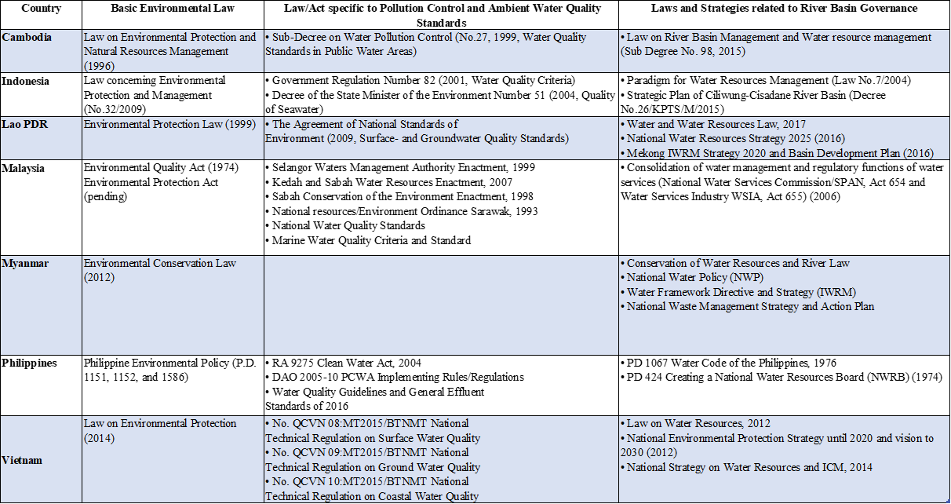

consequence of “siloed approaches” to developing and managing watershed and coastal areas on a sector-by-sector basis; b) there is a lack of available scientific knowledge and input to water resource management and environmental flows in the river basins and associated coastal areas, which could help solve conflicting uses of water and ecosystem functionality and health (e.g., extreme variations in hydraulic flow conditions as a consequence of upstream dam (hydro-electric and irrigation) operations; c) there is limited technical capacity to address complex, inter-related pollution reduction problems (e.g., untreated and partially treated domestic and industrial wastewaters being discharged into the rivers and coastal waters; municipal, industrial and institutional solid wastes being dumped directly and indirectly into rivers and drainage systems and flushing to coastal waters; nutrient runoff from agricultural lands and livestock rearing areas; erosion and sedimentation from deforested land areas due to uncontrolled urban and agricultural development) and climate hazards (e.g., flooding; droughts; landslides; etc.) in an holistic manner; d) there is limited enforcement of policy and regulatory frameworks to protect water resources and related ecosystems; e) there is insufficient investment to meet the specific needs and conditions across the river basins and coastal areas; and f) there is a lack of monitoring data and information on water quality, water quantity and water use across sectors and sources/loadings of land-based pollution. Figure 1 provides a snapshot of the status of IRBM governance at the national and river basin levels in the 7 countries prior to project start-up.

LME projects undertaken in the region (Table 3) have also highlighted the significance of land-based pollution and its impact on the coastal and marine environment. Ongoing and planned SAP implementation programs, such as the upscaling of PEMSEA’s SDS-SEA, clearly complement IRBM initiatives of countries with their focus on transboundary issues, such as land- and sea-based pollution, habitat degradation, impairment of ecosystem services, and climate change. The investment by GEF in integrated river basin and coastal management is fully aligned with the mission of the SDS-SEA 2015 to foster and sustain healthy and resilient oceans, coasts, communities and economies across the Seas of East Asia through integrated management solutions and partnerships. The strategy specifically notes the importance of “…extending the implementation of integrated watershed development and management programmes to all major river basins, lakes, and international water systems in the region….”

Figure 1: IRBM Governance at the National and River Basin Levels in Participating Countries

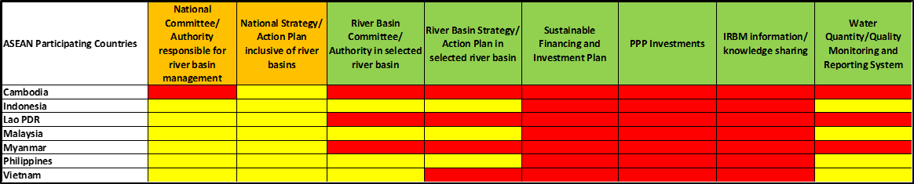

Table 4: Highlights from Transboundary Diagnostic Analyses (TDAs) and Strategic Action Programs (SAPs) of Applicable LMEs in the Asia-Pacific Region

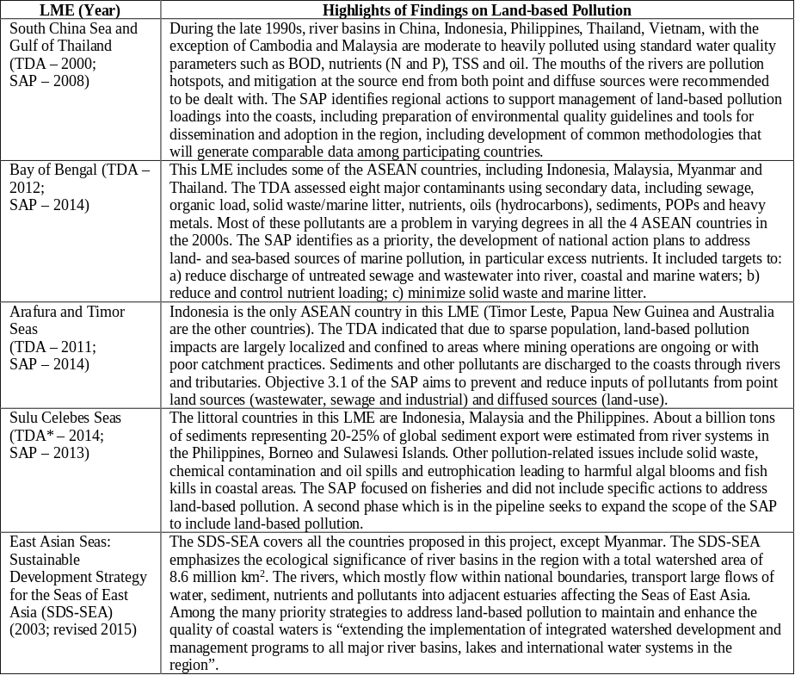

C. Describe the budgeted m &e plan:

Type of M&E activity | Responsible Parties | Budget USD  Excluding project team staff time | Time frame
Inception Workshop | Regional Project Manager, National Implementation Partners,  UNDP Country Offices,  UNDP GEF | USD 20,000 | Within first three months of project start up
Inception Report | Project Team,  UNDP Country Offices | None | Immediately following inception workshop
Measurement of Means of Verification for Project Purpose Indicators | Regional Project Manager will oversee the hiring of specific studies and institutions, and delegate responsibilities to relevant team members | USD 55,000 | Start, mid and end of project
Measurement of Means of Verification for Project Progress and Performance (measured on an annual basis) | Oversight by Regional Project Manager,  Project team | USD 120,000 | Annually prior to ARR/PIR and to the definition of annual work plans
ARR and PIR | Project Team,  UNDP Country Offices,  UNDP-GEF | None | Annually
Quarterly progress reports | Project team | None | Quarterly
CDRs | Regional Project Manager | None | Quarterly
Issues Log | Regional Project Manager  UNDP Country Office Programme Staff | None | Quarterly
Risks Log | Project Manager  UNDP Country Office Programme Staff | None | Quarterly
Lessons Learned Log | Regional Project Manager  UNDP Country Office Programme Staff | None | Quarterly
Midterm Review | Project team,  UNDP Country Offices,  UNDP-GEF Regional Coordinating Unit,  External Consultants (i.e., evaluation team) | USD 50,000 | At the mid-point of project implementation.
Terminal Evaluation | Project team,  UNDP Country Offices,  UNDP-GEF Regional Coordinating Unit,  External Consultants (i.e., evaluation team) | USD 75,000 | At the end of project implementation
Terminal Report | Project team,  UNDP Country Offices,  Local consultant | USD 10,000 | At least one month before the end of the project
Lessons learned | Project team,  UNDP-GEF Regional Coordinating Unit (suggested formats for documenting best practices, etc.) | USD 5,000 | Yearly
Audit | UNDP Country Offices,  Project team | USD 60,000 | Yearly
TOTAL INDICATIVE COST  Excluding project team staff time and UNDP staff and travel expenses |  | USD 395,000

PART iII: certification by gef partner agency(ies)
- GEF Agency(ies) certification
This request has been prepared in accordance with GEF policies and procedures and meets the GEF criteria for CEO endorsement under GEF-6.

Agency Coordinator, Agency Name | Signature | Date  (Month, day, year) | Project Contact Person | Telephone | Email Address
Adriana Dinu  UNDP-GEF Executive Coordinator |  | 13 Nov 2018 | Jose Erezo Padilla | +66 80 604 4435 | jose.padilla@undp.org

ANNEX A: PROJECT RESULTS FRAMEWORK

This project will contribute to the following Sustainable Development Goal (s): 6/11/13/14/17
This project will contribute to the following country outcome included in the UNDAF/Country Programme Document:
Cambodia: By 2018, people living in Cambodia, in particular youth, women and vulnerable groups, are enabled to actively participate in and benefit equitably from growth and development that is sustainable and does not compromise the well – being or natural or cultural resources of future generation.

Indonesia: Strengthened climate change mitigation and adaptation and environmental sustainability measures in targeted vulnerable provinces, sectors and communities.
Lao PDR: Forests and other ecosystems are protected and enhanced, and people are less vulnerable to climate-related events and disasters.

Malaysia: Implementation of a national development agenda that enables green growth through climate - resilient measures, sustainable management of energy and natural resources, and improved risk governance.
Myanmar: By 2022, Myanmar becomes more resilient to climate and disaster risk with efficient environmental governance and sustainable use of natural resource.
Philippines: National and local government and key stakeholders ensure that urbanization, economic growth, and climate change actions are converging for a resilient, sustainable and equitable development path of communities.
Vietnam: By 2021, Viet Nam has accelerated its transition to low-carbon and green development, and enhanced its adaptation and resilience to climate change and natural disasters, with a focus on empowering the poor and vulnerable groups.
This project will be linked to the following output of the UNDP Strategic Plan: Output 1.3: Solutions scaled up for sustainable management of natural resources, including sustainable commodities and green and inclusive value chains.
 | Objective and Outcome Indicators | Baseline | Mid-term Target | End of Project Target | Data Collection Methods and Risks/Assumptions
Project Objective:  To improve integrated water resources management, reduce pollution loads from nutrients and other land-based activities, sustain freshwater environmental flows, and reduce climate vulnerability through demonstrations and replications, planning and strengthening of integrated river basin management in selected countries in the East Asian Seas. | 1. Natural resources that are managed under a sustainable use, conservation, access and benefit-sharing regime. | - 4 Large Marine Ecosystems (Bay of Bengal, South China Sea, Gulf of Thailand and Indonesia Sea) | - 4 Large Marine Ecosystems (Bay of Bengal, South China Sea, Gulf of Thailand and Indonesia Sea) | - 4 Large Marine Ecosystems (Bay of Bengal, South China Sea, Gulf of Thailand and Indonesia Sea) | Assumptions: Note that the project will contribute to reducing pollution loadings transported through national river systems feeding these 4 LMEs.
 | 2. Number of shared water ecosystems (fresh or marine) under cooperative management.

Outcome | Objective and Outcome Indicators | Baseline | Mid-term Target | End of Project Target | Data Collection Methods and Risks/Assumptions
 | 3. Number of women and men as direct beneficiaries of project activities | - 0 | - Direct beneficiaries of project IRBM/ICM and special skills training: women: 500, men: 500 | - Direct beneficiaries of the project IRBM investments at hotspot locations in 7 river basins/ coastal areas (e.g., pollution reduction waste management; water supply/ security; reduced vulnerability): Women: 1% of RB population; Men: 1% of RB population. | - Baseline assessments/gender analysis  - Training workshop reports  - Monitoring reports on field interventions  - Case studies on investment projects
Risks: Resource users could be reluctant to participate in project activities.

Assumptions: Women’s and men’s participation is assumed consistent with findings of stakeholder consultations and general practice at the project sites.

Outcome | Objective and Outcome Indicators | Baseline | Mid-term Target | End of Project Target | Data Collection Methods and Risks/Assumptions
COMPONENT 1: BASELINE ASSESSMENT OF SOURCE TO SEA MANAGEMENT CONTINUUM
Outcome 1: Improved understanding of governance, socioeconomic, ecological conditions, gaps and needs of priority river basins/sub-basins and coastal areas. | Outputs:  1.1.1 Bio-physical profiles prepared/updated covering: a) land uses in the watershed and coastal delta, including significant planned development; b) conjunctive uses of water; c) changes and trends in river water flows and quality over time (including groundwater if available) and d) other biophysical considerations.  1.1.2 Socio-economic and demographic profiles prepared/updated covering existing and forecast growth/development in the respective river basins/sub-basins and coastal areas.  1.1.3 Governance and management systems assessed in each of the selected river basins/sub-basins and corresponding coastal areas, including IRBM and ICM institutional arrangements, policies, legislations/regulations, enforcement, stakeholder participation (including indigenous people, women, and the youth), management, scientific and technical capacities, and current levels of financing for source to sea management.  1.1.4 Rapid assessment of land-based pollutant loadings and sources conducted using total pollutant loading models; the impact of existing and planned developments and growth in the river basins assessed in the context of national and local policies and regulations as well as in the context of the corresponding TDAs and SAPs in the various LMEs, particularly regarding the objectives and/or agreed reductions in nutrient and pollution loads from the rivers into the coastal waters and LMEs where available.  1.1.5 Competing uses, and users of water analyzed to assess existing and future water uses and the implications on the applicable water/food/energy/ ecosystem security nexus at the basin/sub-basin level.  1.1.6 Information and knowledge gained from the profiling and modeling activities consolidated into baseline assessments for the 7 priority river basins and coastal areas, including existing and forecast conditions, gaps and needs in governance and management; baseline assessments disseminated to national and local governments and other concerned stakeholders in the respective countries for validation, awareness, and consensus building.
 | 4. Improved understanding of governance, socioeconomic, ecological conditions, gaps and needs of priority river basins/sub-basins and coastal areas. | - Absence of comprehensive bio-physical and socio-economic profiles of 7 selected river basins/sub-basins and coastal regions  - Existing IRBM governance mechanisms not functioning effectively (Indonesia, Malaysia, Philippines, Vietnam); or not yet established (Cambodia, Lao PDR, Myanmar).  - Lack of scientific data/monitoring information on pollutant sources and pollutants loadings in river basins and coastal regions.  - Competing uses of water resources evident across the different sectors, but not evaluated.  - Absence of comprehensive methodology, indicators, metrics or reporting system for assessing IRBM governance and management | - Bio-physical and socio-economic profiles completed for 7 river basins  - Existing river basin governance mechanisms/ institutional arrangements reviewed and evaluated; interim governance mechanisms set up in priority river basins in Cambodia, Lao PDR, and Myanmar.  - TPLs completed in 7 rivers basins and coastal areas as a rapid assessment of total pollutant loadings and primary sources of pollution in the river basins and coastal regions.  - Template process/survey conducted to identify and assess competing uses and users of water in priority hotspot demonstration sites in 7 rivers/ coastal marine waters.  - State of River Basin reporting system (SORB) developed; SORB baseline assessments reports completed in 7 river basins (linked to Outcome 3.1 on IRBM indicators). | - SORB Reports (end of project) completed and used by river basin organizations as input to planning and development of IRBM strategies and action plans in 7 river basins/sub-basins. | - Bio-physical and socio-economic profiles  - Technical reports on TPL and socio-economic surveys  - SORB (baseline) report  - SORB (end-of-project) report  - Project monitoring reports  - Project Board meetings
Risk:
- Lack of data on environmental flows, including water, sediment, pollutants, litter, etc., socio-economic, and demographic characteristics inhibits baseline profiles and SORB reporting.

Assumptions:
- National agencies and scientific institutions in each participating country are committed to provide available data to complete the profiles; pollutant loading modeling will facilitate rapid assessment of priority pollutant loadings and hotspot locations in each river basin; water use surveys provide qualitative information on water use conflicts and threats; environmental monitoring programs developed or improved and implemented during the project.

- TPL models are applied in cases where monitoring data are limited; environmental monitoring programs to be developed or improved and implemented during the project will be used to validate the models.

 | Objective and Outcome Indicators | Baseline | Mid-term Target | End of Project Target | Data Collection Methods and Risks/Assumptions
COMPONENT 2: IRBM PILOT PROJECTS FOR IMPROVED GOVERNANCE OF RIVER BASINS/SUB-BASINS AND ASSOCIATED COASTAL AREAS
Outcome 2.1 IRBM pilot projects implemented to demonstrate governance mechanisms and instruments for improved source to sea management in 7 priority river basins/sub-basins and coastal areas. | Outputs:  2.1.1 Detailed baseline assessments and feasibility studies conducted for IRBM pilot project development, financing and implementation at hotspot locations in 7 priority river basins/sub-basins and coastal areas.  2.1.2 Agreements signed and implemented with national agencies, local governments, private sector and other interested partners to finance, construct, operate, assess. and report on IRBM pilot projects in 7 priority river basins/sub-basins and coastal areas in accordance with agreed indicators, monitoring programs, and metrics.
 | 5. IRBM pilot projects providing measurable social, economic and environmental benefits to local hotspot locations as well as lessons and good practices for improved S2S management. | - 0 | - Detailed baseline assessments completed at 7 hotspot locations; priority issues/sources identified.  - Feasibility studies completed at 7 hotspot locations; public consultation and consensus building processes conducted.  - Technical and financing options for IRBM pilot projects agreed upon; agreements signed with responsible national and local governments to proceed with IRBM pilot demonstration projects. | - Subject to government approval and investment commitments, 7 IRBM pilot projects commissioned, operational and providing quality information on social, economic and environmental benefits and impacts for local communities and river basin hotspots, as well as lessons and good practices for improved S2S management. | - Public consultation proceedings/reports  - River basin coordinating committee meeting reports  - Project Board meeting reports  - Decisions of national and local government planning and development authorities
Risks:
- Insufficient capacity to develop bankable, sustainable investment projects that respond to public demand/priorities for required infrastructure and services
- National and local governments and river basin authorities are reluctant to commit to investments
- Delays caused by lack of adequate and acceptable financing

Assumptions:
- Baseline commitments of national and local governments and river basin authorities are satisfactory and representative.
- There is political and financial commitment at both levels of government.

Outcome | Objective and Outcome Indicators | Baseline |  | Mid-term Target |  | End of Project Target | Data Collection Methods and Risks/Assumptions
Outcome 2.2: Integrated river basin management strategies and action plans in 7 priority river basins/sub-basins and coastal areas formulated, adopted and initiated. | Outputs:  2.2.1 Assessments and recommendations for improved interagency and multisectoral governance structures in priority river basins/sub-basins developed and disseminated.  2.2.2 Assessments and recommendations for improved IRBM policies, laws, financial and economic instruments, and support programs in priority river basins/sub-basins and coastal areas developed and disseminated.  2.2.3 Seven IRBM strategies and action plans developed and endorsed to the appropriate Ministers, Heads of Government Agencies and Authorities, as appropriate in each country, for adoption and implementation of the plans.
 | 6. No. of IRBM management strategies and action plans adopted and initiated with adequate human and financial resource commitments from national and local governments. | - River basin/sub-basin actions plans completed in the Philippines (Imus Ylang-Ylang River Basin) and Indonesia (Ciliwung-Cisadane River Basin). Human and financial resource commitments to action plan implementation are limited; no major environmental infrastructure in place. | - IRBM Guide to Improved Governance and Management of Rivers and Coastal Areas in the ASEAN Region published and disseminated.  - Assessment of IRBM institutional arrangements, polices, laws, economic instruments governance, action plans, capacities and financing mechanisms completed in 7 priority river basins/sub-basins and coastal areas; 7 assessment reports, including recommended improvements, published and disseminated. |  | - IRBM strategies and 10-year action plans endorsed with indicative commitments of adequate human and financial resources to initiate the action plans in 7 priority river basins/sub-basins and coastal areas. |  | - Technical reports  - IRBM strategies and action plans  - Decisions of national/local authorities for river basins/sub-basins  - Project Board meeting reports
Risk:
Enabling decisions required for adopting and initiating the strategies and action plans are delayed.

Assumption:
The time required for building awareness and consensus among decision-makers on the strategies and actions plans is sufficient.

Outcome | Objective and Outcome Indicators | Baseline |  | Mid-term Target | End of Project Target |  | Data Collection Methods and Risks/Assumptions
COMPONENT 3: KNOWLEDGE MANAGEMENT AND LEARNING
Outcome 3: Improved IRBM knowledge management/sharing and enabling capacities among participating countries, partners and networks. | Outputs:  3.1.1 Technical report/guide for a harmonized set of IRBM governance and management indicators on inputs, process, socioeconomics, governance, stress reduction, and environmental status, among others, developed, published and disseminated.  3.1.2 Improved IRBM water quality/monitoring and reporting programs implemented in connection with IRBM pilot projects in 7 priority river basins/sub-basins and coastal areas.  3.1.3 Core capacities and skills in IRBM development and management transferred to Project Team members, managers and implementers of IRBM projects in 7 priority river basins/sub-basins and coastal areas.  3.1.4: Regional IRBM knowledge management, knowledge sharing and communication platform including project operationalized.  3.1.5: One percent of the GEF grant allocated for participation in regional and global forums, preparation of experience notes, and organization and conduct of regional twinning activities in collaboration with GEF LME/IW Learn.
 | 7. Core groups of IRBM managers and implementers, universities, NGOs and the business sector enabled and supporting river basin organizations with the execution of IRBM strategies and action plans. | - Water quality monitoring being implemented in: Ciliwung River/ Jakarta Bay (Indonesia); Kedah River/Malacca Strait (Malaysia); Imus-Ylang Ylang and Pasac Guagua Rivers/ Manila Bay (Philippines); and Vu Gia – Thu Bon Rivers/ Da Nang Bay (Viet Nam).  - Limited capacity/skills and experience among IWRM and ICM programs in the region on S2S continuum, governance and management. Several national and regional knowledge sharing events are being organized each year by ASEAN, PEMSEA and GEF-supported LMEs, as well as other bilateral and multilateral donor- supported projects. S2S management and decision-support tools are not being addressed in an integrated manner thus far.  - National and sub-national water quantity and quality monitoring and reporting systems for priority rivers partially in place in 5 countries (Cambodia, Indonesia, Malaysia, Philippines, Vietnam).  - IW learn regional workshop conducted in April 2018 in Bangkok; development of regional IW/LME KM sharing platform explored; PEMSEA introduced its SEA Knowledge Bank platform. | - Harmonized set of IRBM governance and management indicators adopted and incorporated into SORB baseline reports across the 7 priority river basins/sub-basins and coastal areas.  - IRBM/ICM training and IRBM special skills training modules developed; regional and river basin IRBM training programs and schedules prepared and initiated, with at least 50% of the trainees being women.  - Completion of project mid-term review, submitted for review and approval by the Project Board and UNDP, and uploading to the regional knowledge platform.  - Timely delivery of quarterly and annual reports in accordance with GEF and UNDP M&E requirements.  - Water quantity and quality data collection, M&E mechanisms and capacities reviewed in 7 river basins/sub-basins.  - Participation in all GEF IW Conferences to held during implementation of the project to facilitate cross-regional collaboration and knowledge sharing on IRBM implementation by ASEAN Member States.  - Design and construction of a regional IRBM knowledge portal/website; initial set of IRBM knowledge products developed and disseminated (e.g., IRBM training modules; SORB guideline; RB-IIMS and TPL user manuals). |  |  | - End-of-project SORB reports provide policymakers, planners, managers and the general public with information on the impacts and benefits of IRBM pilot projects, as well as gaps, needs and priorities for up-scaling to the river basin/sub-basin and coastal area.  - River basin organizations and project teams in priority river basins/sub-basins and coastal areas capacitated and initiating IRBM strategy and action plans in 7 priority river basins/sub-basins and coastal areas; regional technical/scientific support networks set up to provide advice and assistance to river basin organizations and project teams.  - Completion of the project terminal evaluation for review and approval by the Project Board and UNDP, and uploading to the regional knowledge platform.  - Timely delivery of quarterly, annual reports and end-of-project report in accordance with GEF and UNDP M&E requirements.  - Scientifically sound water quantity and quality M&E mechanisms developed and initiated at hotspot locations and providing input to M&E reporting in accordance with common set of IRBM indicators.  - Regional IRBM knowledge-sharing platform fully functional, including access to knowledge products and support services produced by the project, as well as linkages to other related KM platforms, at the national, regional and global levels, including the IW/LME Learn platform and regional training and outreach program. |  | - Regional workshop report on identification and selection of IRBM stress indicators  - National and regional training workshop reports  - SORB (baseline and end-of-project) reports  - Project Board meeting reports  - GEF IW conference proceedings  - GEF regional workshop/knowledge sharing reports  - Quarterly and annual reports prepared by the Regional IRBM Project Manager and submitted to UNDP and the Project Board for review and approval.
Risks:
- Project implementation is taking place in 7 countries at national and sub-national levels concurrently. Varying capacities, skills, knowledge, access to resources, information and technologies constrain planning and development of IRBM at the national and river basin/sub-basin levels.

- Varying interests, capacities, skills, knowledge, access to resources, information and technologies constrain upscaling of IRBM across the priority river basins/sub-basins and coastal areas.

- Delays in submission of progress reports from 7 project sites could affect the timely delivery of the quarterly and annual reports.

Assumptions:
- Capacity building initiatives will address existing needs and gaps at national and local levels by: a) supporting cross-learning, region-wide knowledge sharing activities on IRBM development and implementation, as well as b) customized special skills training and hands-on experience at the river basin/sub-basin level, as required for project planning and implementation.

- National and local governments have indicated their interest and support for strengthening IRBM governance and management and the opportunity to set up IRBM pilot demonstration projects in the priority river basins and sub-basins and coastal areas.

- Project Teams and coordinating units are capable and fully recognize the objectives and benefits of timely and quality M&E reporting.

ANNEX B: RESPONSES TO PROJECT REVIEWS (from GEF Secretariat and GEF Agencies, and Responses to Comments from Council at work program inclusion and the Convention Secretariat and STAP at PIF).

Comments | Agency Response
GEF SECRETARIAT:
- During PPG, more information will be collected and analyzed regarding existing initiatives in the selected river basins and how this project will build on these initiatives. A clear explanation of the basis for selecting the river basins also needs to be thought through during PPG and agreed with the countries. The current explanation is limited to "source-to-sea considerations", which is unclear. This is particularly important to ensure the countries are using these agreed criteria as the basis for considering sites | - During the PPG Inception Workshop (August 2017), the 7 participating countries developed and agreed to criteria for the selection of river basins for the IRBM project. The criteria were stated in the form of 6 questions, namely:  a) Is the candidate site identified as a priority river basin by the national government? Why?  b) Is the receiving near coastal area and sea area identified as a priority coastal and marine area? Why?  c) Is there an adequate foundation of information and knowledge of the candidate site?  d) Are there previous or ongoing programs or projects at the candidate site covering governance and management?  e) Are scientific data available for decision-making and planning in the source-to-sea system covering land resource and water system? Who has the data? How are the data shared and used?  f) Is there investment by governments, donors, the private sector and others in river basin/coastal area planning and development. Who is investing and what are the investments for?  The countries agreed that if the answer was “NO” to three or more of the six questions, then the candidate site may not be appropriate site for the IRBM project, given its objectives, budget and limited duration.  Upon applying the selection criteria, four of the seven participating countries changed the river basins/sub-basins from those identified in the PIF (i.e., Indonesia, Myanmar, Philippines, and Vietnam).  Information on the analysis and selection of river basins within each country is summarized in the National IRBM Project Proposals (Annex K), including identification of ongoing and planned initiatives (governance, management, scientific, investment) in each river basin that will serve as a foundation for the IRBM project.  The criteria for selection of priority river basins and the final list of selected priority river basins can be found in Section IV, Results and Partnerships, of the Project Document.
- Project Outputs 2.1.1 and 2.2.2 seem to be duplicative, which needs to be resolved during PPG. If 2.2.2 is intended to be the implementation of the IRBM plans developed through 2.1.1, then that needs to be clear. | - Based on inputs from government and non-government stakeholders in the 7 participating countries, as well as the downsizing of the project budget from $11.5 million to $8.47 million, the outputs in Component 2 have been modified. As explained in the introduction to Component 2, the project has adopted a four-tiered approach (regional, national, river basin, local) to planning, development and implementation of the IRBM project and its outputs. Output 2.1.1 focuses on the local tier, and involves developing and implementing an IRBM pilot project at an identified hotspot location in each river basin. The pilot projects will serve as learning experiences for improved IRBM governance and management, from which to build and up-scale IRBM to the river basin/sub-basin tier.  Outputs 2.2.1 and 2.2.2 relate to the river basin/sub-basin tier and are about reviewing and assessing options for improving: a) governance and institutional mechanisms; and b) IRBM policies, laws, financial and economic instruments, and support programs in the priority river basins. Outputs 2.2.1 and 2.2.2 result in assessment reports, which will include options for improving governance and governance instruments as well as action agenda for change. Output 2,2.3 involves developing, building consensus, adopting and initiating IRBM strategies and action plans in the 7 priority river basins. The IRBM strategies and action plans will incorporate action agenda that were identified in the assessment reports, as modified and agreed to through a public consultation process, in addition to inputs from SORB reports, good practices and lessons from pilot projects, and the development goals and objectives of river basin organizations, local governments, communities and social and economic sectors in the river basin and coastal region. The strategies and action plans will be submitted to the respective government approval processes for adoption.  As indicated in Output 2.2.3, initiation of adopted river basin strategies and action plans will specifically target commitments of adequate human and financial resources to scale-up or replicate at least one priority management intervention in each river basin.
- For the indicators developed as part of output 3.1.1 please be sure to include socioeconomic and governance indicators as well as ecological indicators. | 3. Changes have been made to Output 3.1.1 based on comments received from STAP, as follows:  Activity 3.1.1.1: Conduct a desk study of indicators and monitoring and evaluation reporting systems that are being applied at the national, regional and global levels to assess the progress, impacts and benefits derived from ICM, IWRM, IRBM projects and programs, such as the Mekong and Red Rivers, as well as ASEAN Strategies and Action Plans, PEMSEA’s SDS-SEA and other SAPs for LMEs/regional and sub-regional sea areas, and relevant international instruments, including the UN SDGs and international conventions and instruments such as ICCC, CBD and the Aichi Biodiversity Targets, and the Sendai Framework.  Activity 3.1.1.2: Prepare a technical report/guide based on the desk study, recommending a list of SMART indicators (e.g., socio-economic, governance, stress reduction, environmental status, among others) to be used in monitoring, evaluating and improving IRBM planning and implementation. Indicators will be gender specific where appropriate. The listing will also include guidance on how the indicators can be used and by whom in developing, implementing and managing IRBM programs. Disseminate the draft report/guide to relevant organizations and individuals in participating countries and organizations for review and comment.
- During PPG it needs to be clarified that the river basin investment will be fully aligned with the mission of the SDS-SEA 2015 strategy's mission to foster and sustain healthy and resilient oceans, coasts, communities and economies across the Seas of East Asia through integrated management solutions and partnerships. The Strategy specifically notes the importance of, "... Extending the implementation of integrated watershed development and management programmes to all major river basins, lakes, and international water systems in the region..." | 4. The point has been clarified in the last paragraph in Section II, Development Challenge, of the Project Document. Furthermore, approaches (i.e., pilot demonstration of IRBM), tools (i.e., IIMS, SOC); and networks (i.e., network of local governments; network of learning centers, business network) identified and promoted in the SDS-SEA 2015 have been incorporated into the planned activities of the IRBM project to strengthen linkages and promote cost effective and efficient project implementation.
- Finally, in the Pro Doc it needs to be clarified that the "8 IRBM plans will be submitted to responsible government authorities for review and signature by ministers to ensure national support at sufficient levels." (Output 2.2.2) | 5. Outcome 2.2 is revised to refer to only 7 priority river basins/sub-basins and coastal areas.  Output 2.2.3 (changed from 2.2.2 as explained in Comment 2, previously) now states, “Seven IRBM strategies and action plans endorsed to the appropriate Heads of Government Agencies and Authorities responsible for adoption and implementation of the plans.”  The rationale is that the responsible agency, authority and signatory for approval of IRBM management plans differs from country to country and does not necessarily require the signature of a Minister to be adopted.  Activites under Output 2.2.3 target the initiation of the adopted acion plans, with evidence of at least one priority management intervention initiated during the project.
- Please note that the Malaysia OPFP Endorsement Letter which was signed by the previous OFP needs to be updated as soon as possible at latest by CEO Endorsement. | 6. The signed LOE by the current Malaysia OFP was provided earlier to the GEF Secretariat, and is included in Annex J.
USA:
- We are unclear whether the differences in legal regimes, economic systems, demographic and social profiles, and other aspects of the project make it efficient to take it on as a region-wide effort. We request that UNDP provide an explanation of the value of undertaking these efforts on a regional basis. We further request UNDP provide a more specific explanation of the aspects of this project they expect can be undertaken on a region-wide basis versus how much of the project content will be done in a country-specific manner, and how much of the lessons or recommendations they expect to be universal to all the countries involved. | 1. Governance and management challenges among the river basins in the 7 countries are not dissimilar, covering: water pollution (organic, nutrients, toxic and hazardous waste); solid waste; deforestation; biodiversity loss; erosion, siltation, flooding and landslides; water security/water quality (drinking water; recreation; aquaculture); competing uses/water quantity (dams; irrigation; urbanization, domestic and industrial use); and climate change. It is not possible to address all of these challenges, even for one river basin, in this foundational project. The approach of the project is to demonstrate sustainable IRBM solution templates at pilot scale for improved governance, pollution, waste management, deforestation, and water use conflicts, as a starting point to wider change. The application of the template solutions under disparate conditions (i.e., political, legal, social, economic and environmental), provides greater opportunity for replication and up-scaling, recognizing that such differences are not only present among countries of the region, but also within and across river basins/ sub-basins of the countries.  The project is being undertaken within the ASEAN governance framework. ASEAN provides a political agenda and process for leveraging high-level commitments to upscaling and replicating IRBM good practices and investments based on the individual and collective experiences of the countries. The ASEAN Working Group on Water Resources Management (AWGWRM) will serve as the Project Board/Steering Committee for the project. The AWGWRM was established to: promote networking and engage in collaborative action towards the practical implementation of IWRM; promote and facilitate the exchange of relevant information, expertise, technology and know-how among water resource agencies and member countries; and promote and plan for relevant training, education and awareness-raising campaigns. This provides GEF with a unique opportunity to tap into an established network of governments and government agencies in Southeast Asia with a mandate to scale up water resources management.  At the regional level, the project will focus on developing and transferring tools, templates, and enabling capacities to the national and local river basin organizations, managers and project teams, and providing access to a team of IRBM scientific and technical, financial and investment, legal, and socio-economic professionals/specialists to adapt and apply these tools to solve real governance and management issues under local conditions. The regional level activities will also concentrate on monitoring and evaluation of progress, outputs and outcomes, sharing of experiences, lessons and good practices via ASEAN, PEMSEA and other regional organizations and networks, the development and transfer of knowledge products based on the experiences in the river basins, building/ strengthening scientific, technical and financing and investment support networks, and operationalizing an e-knowledge platform to link and promote cooperation among IRBM communities within countries of the region, and with other regions. The regional aspects of the project are included in all three components of the project, and represent 20% of the budget for Component 1 (baseline assessment); 25% of the budget for Component 2 (improved IRBM governance and management); and 75% of the budget for Component 3 (knowledge management and monitoring and evaluation).  At the country level, the existing and interim river basin organizations and project teams will: prepare a baseline State of River Basin Report for each river basin (Component 1) including priorities, gaps and needs for improved IRBM governance and management; plan, develop and implement pilot projects at hot spot locations in each river basin as learning sites/showcases for sustainable IRBM management, financing and investment, (Component 2) including opportunities for scaling up and replicating improved governance and management in the selected river basin based on the experience of the pilot projects; and packaging and transferring experiences, lessons and good practices to other river basins within their country and among participating countries in the regional project (Component 3).  The experiences, lessons, good practices and recommendations coming from the project will benefit all participating countries. Generic tools, processes, and templates for improved IRBM governance and management will be adapted, tested and demonstrated under a variety of political and legal regimes, environmental conditions, economic systems, demographic and social profiles, as well as capacities. This is the advantage of the project, as adaptive management is a critical feature of all IRBM programs. The project does not propose immediate change for all issues across all river basins/coastal areas, but does target full change and solutions for selected hotspot areas (i.e., pilot sites) and key issues (i.e., nutrient reduction; wastewater management; water management) to initiate change at larger scales.
- It is unclear from the proposal whether there is a demand signal and appropriate institutional homes/partners for Component 1 (Baseline Assessment) other than the GEF supported PEMSEA. Particularly on freshwater modelling, the success or failure of this component will rest on finding appropriate avenues to complement or enhance local models and institutions. | 2. During the PPG phase, participating countries concluded the focus of the project would be on enabling improved governance and management of IRBM by addressing key issues to initiate and encourage change. This is an issue that countries are already engaged in, but see the project as an opportunity to boost their capacity and move from a planning focus into on-the-ground implementation.  At the regional level, the ASEAN Working Group on Water Resources Management (AWGWRM) and the ASEAN Working Group on Coastal and Marine Environment (AWGCME) have expressed support for the project. While the AWGWRM will serve as the Project Board for the project, it is expected to coordinate with the AWGCME.
- Regarding the freshwater model, building a pollutant-loading hydrogeological model of this scale takes an incredible amount of data, both historic and current. Validating and verifying the model will require site testing and ground-truthing, which could take a large amount of resources as well. Unless such models currently exist and only need to be specifically tailored for use in the region’s watersheds and LMEs (this is not clear from the proposal), we are concerned that this component is unlikely to be achieved in the given timeframe. We urge UNDP to give greater consideration to how it will assess viable existing databases and models for this component, and re-evaluate whether the proposed timelines and budgets are realistic for this critical component. | 3. During the PPG phase, participating countries concluded that total pollutant loading modelling (TPL) would be conducted for “rapid assessment” purposes only, to estimate loadings of priority pollutants (e.g., nutrients; organics; solids; metals) to rivers and coastal areas, and to identify the primary sources. TPL models are being employed in river basins in Indonesia, Malaysia, Philippines and Vietnam where scientifically-sound monitoring data and databases are limited or not available. The TPL models provide a sense of existing and future pollution hotspot issues and locations in the river basin and coastal region, early estimates of total loadings and where and why they are occurring (e.g., point sources: domestic, agriculture, industry; and non-point sources: land run-off; erosion). The results of the rapid assessments will be included in the baseline state of river basin (SORB) reports (Component 1). The SORB reports will also identify gaps and limitations in available data and monitoring programs, highlighting the benefits of connecting environmental monitoring to investments in IRBM management.  For Component 2, the project will focus on a hotspot locations/issues in the river basin, and conduct a detailed baseline assessment of identified pilot sites. That information will serve as input to feasibility studies and delineation of management options and their potential social, economic and environmental impacts and benefits to the local hotspot, and to the river basin in general. By the end of the project, the objective is to set up a comprehensive monitoring, evaluation and reporting system in the hotspot location. The focused monitoring program will measure changes that are occurring in the local community and environment, the impacts and benefits derived from the pilot project, and the value of scaling up to other hotspot locations in the river basin/sub-basin.
- Further, we urge UNDP to re-evaluate the budget and co-financing more generally to ensure that the funds are adequate to accomplish all of the planned activities and projected outcomes. | 4. Based on inputs from government and non-government stakeholders in the 7 participating countries during project preparation, as well as downsizing of the project budget from $11.5 million to $8.47 million, project outputs have been modified.  The project has adopted a four-tiered approach (regional, national, river basin, local) to planning, development and implementation. Output 2.1.1 focuses on the local tier, and involves developing and implementing an IRBM pilot project in an identified hotspot location in each river basin. The pilot project will serve as a learning site for improved IRBM governance and management, from which to build and up-scale IRBM to the river basin/sub-basin tier in the future.  Outputs 2.2.1 and 2.2.2 relate to the river basin tier and are about reviewing, assessing and providing options for improving: a) governance and institutional mechanisms; and b) IRBM policies, laws, financial and economic instruments, and support programs in the priority river basins. Outputs 2.2.1 and 2.2.2 will be in the form of assessment reports, which will include options for improving governance and governance instruments, as well as action agenda for change that will be developed through public consultation. Output 2.2.3 involves developing, building consensus, adopting and initiating IRBM strategies and action plans in the 7 priority river basins. The strategy and action plans will be submitted to the respective government approval processes for adoption. Initiation of adopted river basin strategies and action plans will specifically target commitments of adequate human and financial resources to scale-up or replicate at least one priority management intervention in each river basin.  The national tier ensures cooperation and involvement of central agencies in the planning and coordination of central agency support and advisory processes to the project. Again, existing coordinating mechanisms will be employed, with National Implementing Partners taking the lead in coordinating input to the project. It is also at this level that linkages to and synergies with the respective LME SAPs and corresponding national action plans will be facilitated through the existing national implementing mechanisms.The national agency representatives will be able to use the experience to catalyze the development or improvement of national IRBM policies, institutional mechanisms, laws, etc. It is recognized, however, that the development and improvement of national IRBM governance mechanisms and instruments will not be deliverables under the current project due to limited project duration and budget.  It must be emphasized that the capital financing for the planned pilot projects is beyond the available budget of this IRBM project. Thus, one of the major challenges that Component 2 will address is to put in place the partnerships and financing structure for the pilot projects. This, in fact, is the major stumbling block currently faced by local governments and river basin organizations. By walking local governments and river basin organizations through the process of project development, financing and sustainable implementation, a legacy of approaches, experiences and networking will be created. In particular, the project will facilitate the development and assessment of financing options (e.g., public, public-private, private) and partnership arrangements. One innovative financing option to be explored is referred to as a “PPP Inclusive Growth Fund”. This option will assess opportunities for an effective and equitable financing structure that facilitates pro-active participation of the private sector, the government and the community in the financing, ownership and operation of the pilot project.
- The proposal requires additional information on nutrient sources to the sea, such as agricultural operations (chemical fertilizers, aquaculture, and coastal runoff), urban wastewater, and industrial effluents. Without some quantification of nutrient sources, it would not be possible to develop nutrient control measures. Some of the Regional Strategic Action Plans (Page 6) tend to address urban sewage and other sources of nutrient pollution. There is a need to review a record of progress under the SAPs, some of which may have been implemented many years ago. | 5. None of the selected river basins has a comprehensive baseline report covering the entire watershed/coastal area. The project will be a first effort at gathering, consolidating and assessing available data from sectoral monitoring programs (environment, health, agriculture) and research projects in the river basins, and using the information as input to a river basin strategy and action plan. The project will also build awareness and consensus on the rationale and benefits of an integrated monitoring program and information sharing system at the river basin level.  There have been no major investments in urban sewerage and other sources of nutrient pollution thus far in the 7 selected river basins.
- Donor-driven IWRM programs have been quite active in the ASEAN region; a majority of the priority national river basin countries have established IWRM policies and basin-level RBOs etc. Please detail how this program will assess these existing efforts, and what kinds of activities and interventions it will use to strengthen them and address impediments to IWRM success. | 6. Annex K of the Project Document, National IRBM Project Proposals, includes a review of existing national policies, legislation and institutional arrangements in each of the 7 participating countries. The project will conduct a comprehensive review of these governance and management instruments to identify their level of application, strengths, limitations and gaps in the planning, implementation, financing and evaluation of national IRBM programs.  At a practical level, the project will develop and implement IRBM pilot projects in hotspot locations in the selected river basins/sub-basins. Each pilot project will be planned and developed within the framework of national and local policies, laws and instruments. Where impediments are identified, the pilot project will introduce and adapt innovations in governance, management, financing and investment to local conditions with the objective of providing concrete evidence of how such adaptations/innovations contribute to on-the-ground results by bridging gaps and shortcomings in existing policy, laws and instruments.  It is not envisaged that this project will result in the adoption of new or amended policies, laws or instruments at the national level within its lifetime. Rather, the objective of the project is to provide a “bottom-up” demonstration of innovations and adaptations in policies, laws and instruments for use by the responsible national authorities in national policy, legislation and program development.
- If large infrastructure projects result from UNDP’s capacity building, we strongly suggest the government do so in a way that does not have a negative impact on social or environmental health. | 7. Templates will be prepared by the project for the planning and implementation of all pilot projects. Pilot projects are expected to cover small to medium-sized investments in pollution reduction/nutrient management (e.g., domestic sewerage and sanitation), erosion/sedimentation (sustainable reforestation), and improved water use/water management (water supply protection and conservation). The templates will provide direction to identify and assess options for overcoming these hotspot issues at each of the pilot sites, as well as building consensus on solutions that provide positive social, ecological and economic benefits to local communities, river basins and coastal regions. Professional advice and support will be provided to governments throughout planning, procurement, construction and operating phases of pilot projects to ensure that social and environmental principles and safeguards are incorporated into all aspects of the projects, and are maintained as key indicators of successful management and operation.
GERMANY:
- Under A.4 Risks: Germany would like to see a mention and evaluation of alternative approaches, especially for the second risk mentioned “lack of national and local political support”. Collecting all the river basin linked data of different uses will touch many and even sensible interests. If there is a lack of political backing, how to proceed? Coalitions of those willing to go ahead may be one option. | 1. The mitigation of risk for “lack of national and local political support” has been expanded upon in Table 6 (Project Risks Assessment and Mitigation Measures). The project will not be able to provide comprehensive coverage of the entire river basin in each country, given the budgetary and time limitations of the project. Pilot projects will be set up in hotspot locations within each river basin to provide templates and experience in IRBM governance, management and investment (Output 2.1.1). The products and experience gained from the pilot projects will then be adapted and applied for up-scaling IRBM on a river basin/sub-basin level (Output 2.2.3). One of the criteria for selection of a hotspot location is political will and commitment from both the national and local governments. Proposed hotspot locations were identified by national and local governments for each river basin/sub-basin during the project preparation phase (Annex K). This is the first step in establishing coalitions between willing partners before the project starts.
- Germany seeks clarification on the role of the ASEAN Centre for Biodiversity (ACB), which is not mentioned in the proposal. The project proposal might benefit from considering potentials of collaboration with the ACB, especially as PEMSEA and ACB closely collaborate on regional marine related topics. | 2. ACB was created by the ASEAN Member States and is a Non-Country Partner of PEMSEA. ACB has been included in the project’s stakeholder engagement plan (Components 2 and 3). ACB’s involvement will include facilitating access to information and expertise in biodiversity conservation strategies, plans and approaches in the 7 countries/river basins in support of enhanced environmental flows and biodiversity conservation and management and their linkage to targets, initiatives and indicators within the NBSAPs of the respective countries.
STAP:
- Component 1 on baseline assessment of source to sea management continuum: this component will focus on gathering and analysing information on bio-physical and land-based pollution. We assume that some scientific analysis (field- and laboratory-based) will be undertaken in this component. No information on the proposed or planned methodology has been provided at this stage. The STAP suggest that this information should be provided during the full project development stage. This will be useful to gauging the scientific and technical suitability and credibility of chosen methodology. | 1. The baseline assessment will focus on gathering, assessing and analyzing available data and information in the river basin and coastal area. There will be no primary data gathering at the river basin level; only secondary data will be used at his point. Data gathering, assessing and analyzing activities in year 1 of the project will be preceded by a regional workshop involving scientists (physical, biological, social) from the region and project teams from each of the river basins, to agree on the scope and coverage, baseline year(s), methodology, sources, data quality, indicators, metrics, data analyses and reporting process (Output 3.1.1). This was not possible during the project preparation phase due to limited budget. STAP participation in the regional workshop would be most welcome.
- Still in component 1, it was stated that some modelling activities for pollutant load and water use will be undertaken. It will also be useful to provide some information on the models that is planned to be used in implementing this activity. The STAP further advise that, if the resources are available, such modelling work should not rely on a single model but should be implemented using multiple modelling tools in order to help improve robustness and scientific credibility and reduce uncertainty of model results. | 2. Given the scope of the project and budgetary constraints (due to budget reduction), modeling will be limited to rapid assessment of total pollutant loadings (TPL) and sources in the river basins. A variety of rapid assessment models are already available in Indonesia, Malaysia, Philippines, and Vietnam. For example, the recently completed GEF/UNEP project entitled, “Global foundations for reducing nutrient enrichment and oxygen depletion from land-based pollution, in support of Global Nutrient Cycle (GNC Project)” developed and successfully demonstrated a rapid assessment model for nutrient loads from human and agricultural activities in the Manila Bay watershed. This model will be introduced to countries that currently have limited capacity in TPL modeling.
- Component 3: No specific output was provided in Table B although the description of the component seems to be littered with potential products that can be termed as outputs. We advise that the expected outputs should be included during the development of the full project. Some possible outputs include: | 3. Table B has been updated in the Project Document to incorporate the comments provided by STAP. Component 3 has one outcome and 5 outputs. The outcome is stated as, “Improved IRBM knowledge management/sharing and enabling capacities among participating countries, partners and networks.” Outputs have been developed as follows:
a. For Outcome 3.1 on common IRBM indicator: A documentation of the list of identified and agreed common indicator including guidance on how these indicators should be used as well as description of mechanisms or tasks and responsibilities for river basin management. | Output 3.1.1: Technical report/guide for a harmonized set of IRBM governance and management indicators on inputs, process, socioeconomics, governance, stress reduction, and environmental status, among others, developed, published and disseminated.  Activity 3.1.1.1: Conduct a desk study of indicators and monitoring and evaluation reporting systems that are being applied at the national, regional and global levels to assess the progress, impacts and benefits derived from ICM, IWRM, IRBM projects and programs, such as the Mekong and Red Rivers, as well as ASEAN Strategies and Action Plans, PEMSEA’s SDS-SEA and other SAPs for LMEs/regional and sub-regional sea areas, and relevant international instruments, including the UN SDGs and international conventions and instruments such as ICCC, CBD and the Aichi Biodiversity Targets, and the Sendai Framework.  Activity 3.1.1.2: Prepare a technical report/guide based on the desk study, recommending a list of SMART indicators (e.g., socioeconomic, governance, stress reduction, environmental status, among others) to be used in monitoring, evaluating and improving IRBM planning and implementation. Indicators will be gender specific where appropriate. The listing will also include guidance on how the indicators can be used and by whom in developing, implementing and managing IRBM programs. Disseminate the draft report/guide to relevant organizations and individuals in participating countries and organizations for review and comment.  Activity 3.1.1.3: Revise the draft report/guide based on feedback; publish and disseminate it to national and local governments, river basin organizations and Project Teams for inclusion in baseline assessments of river basins and State of River Basin Reporting (Output 1.1).
b. For Outcome 3.2 focused on capacity building, training and capacity building initiatives could be considered as the outputs | Output 3.1.3: Core capacities and skills in IRBM development and management transferred to Project Team members, managers and implementers of IRBM projects in priority river basins/sub-basins and coastal areas.
c. For Outcome 3.3 on knowledge and good practice transfer, the knowledge transfer initiative or efforts could be valid output. Along this line, does the project envisage developing a knowledge transfer products such as guidance, or reports that can be used to convey the lessons learnt? We think this will be a useful product that can help further in the replicability of the project. | Output 3.1.4: Regional IRBM knowledge and communication management platform operationalized.  Activity 3.1.4.1: Gather, package, and disseminate knowledge products from the various project activities, events, and outputs, such as good practices, lessons learned, policy briefs, case studies, guidance documents, technical reports, etc., using various formats and content that are readily accessible and understandable by target audiences including political leaders, planners, IRBM managers and practitioners, investors, and the general public.

Annex C: status of implementation of project preparation activities and the use of funds

A. Provide detailed funding amount of the PPG activities financing status in the table below:
PPG Grant Approved at PIF: $288,000
Project Preparation Activities Implemented | GEF/LDCF/SCCF Amount ($)
Project Preparation Activities Implemented | Budgeted Amount | Amount Spent To date | Amount Committed
National Project Consultants (7) | 80,000 | 80,000 | 0
International Project Consultants (2) | 100,000 | 100,000 | 0
Project orientation/planning/validation workshops (30) | 63,000 | 57,708 | 0
Travel | 35,000 | 61,957 | 0
Communications | 2,000 | 509 | 0
Supplies | 3,000 | 1,528 | 0
Miscellaneous | 5,000 | 2,646 | 0
Total | 288,000 | 304,348 | (16,348)*
* co-financing support provided by UNDP Manila and PEMSEA

annex D: calendar of expected reflows (if non-grant instrument is used)

Provide a calendar of expected reflows to the GEF/LDCF/SCCF Trust Funds or to your Agency (and/or revolving fund that will be set up)

Not Applicable
ANNEX E: PROJECT MAPS AND COORDINATES

Cambodia
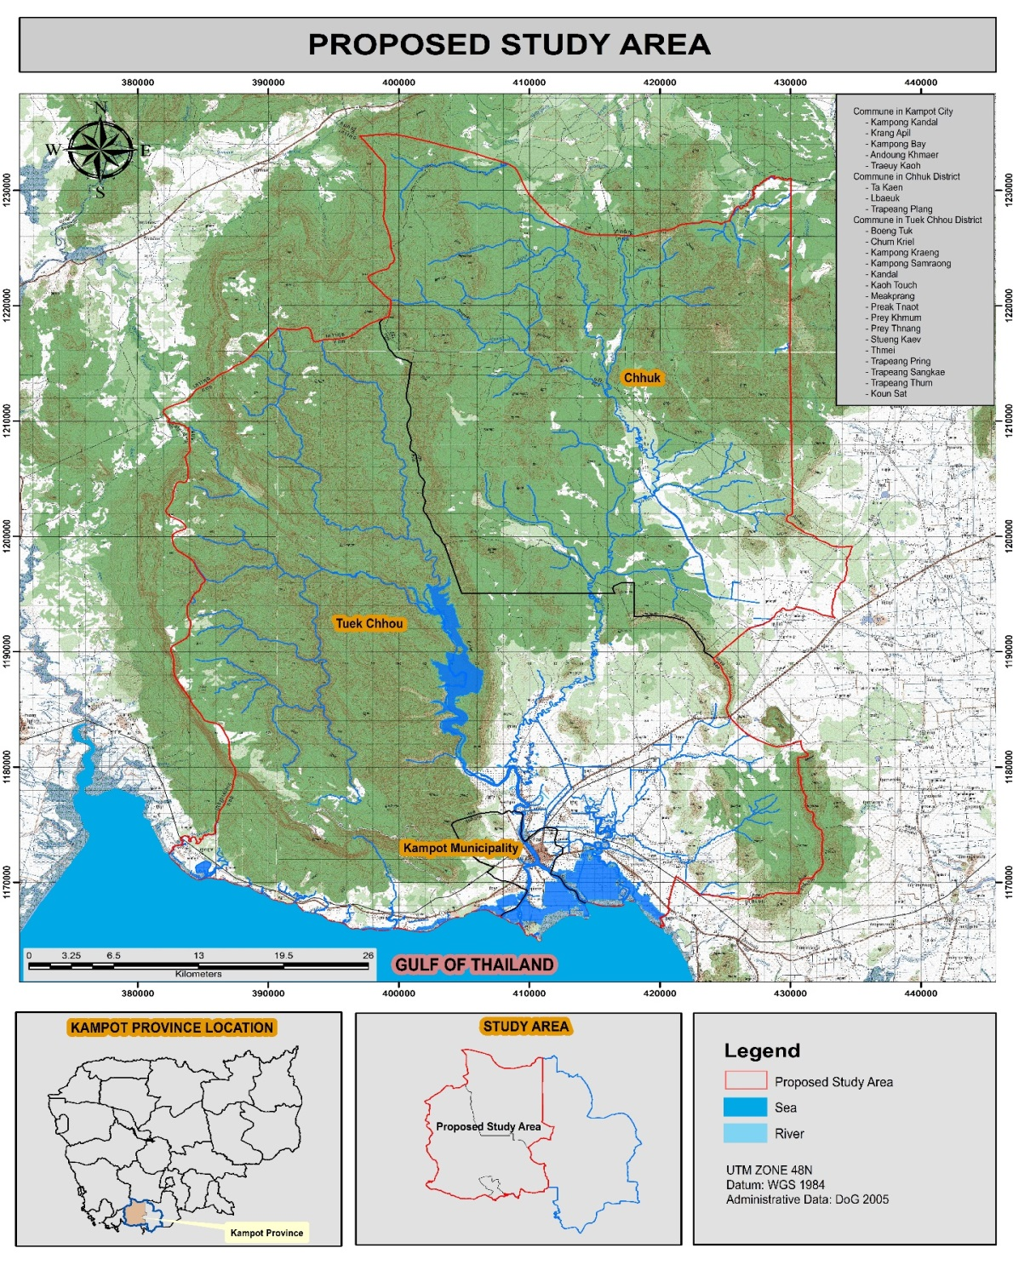

Indonesia
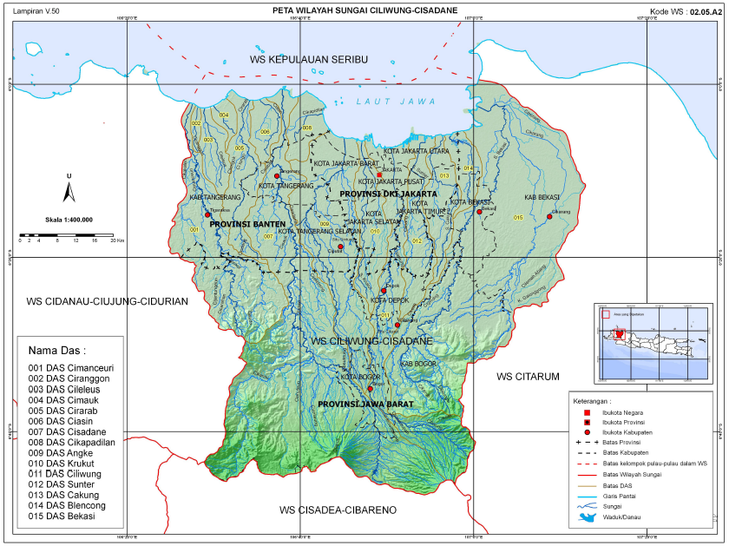

Lao PDR
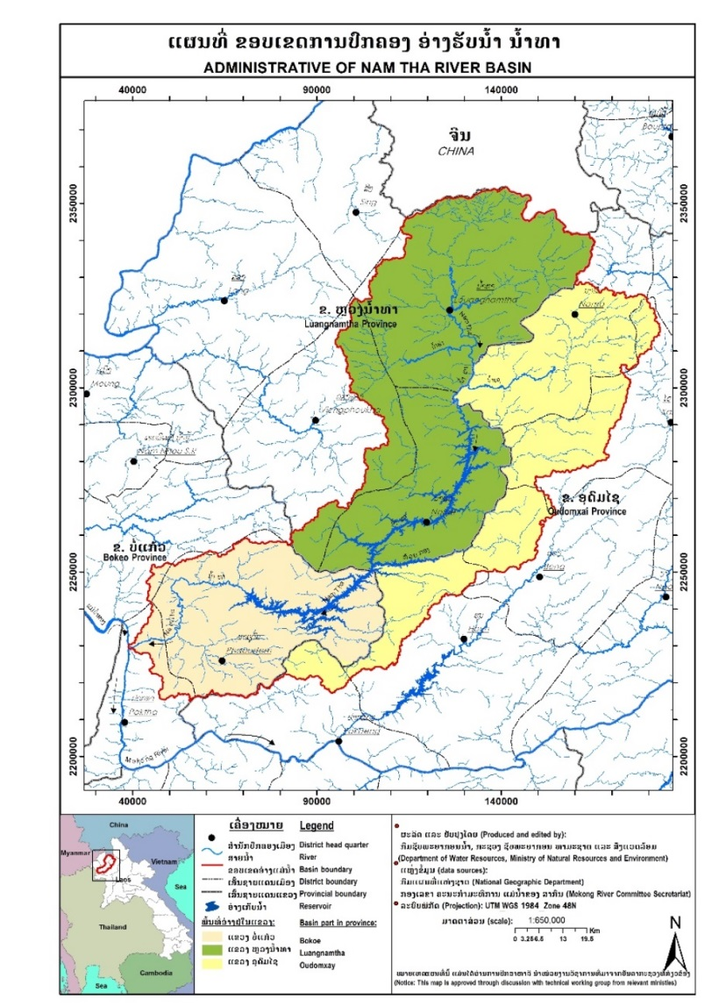

Malaysia
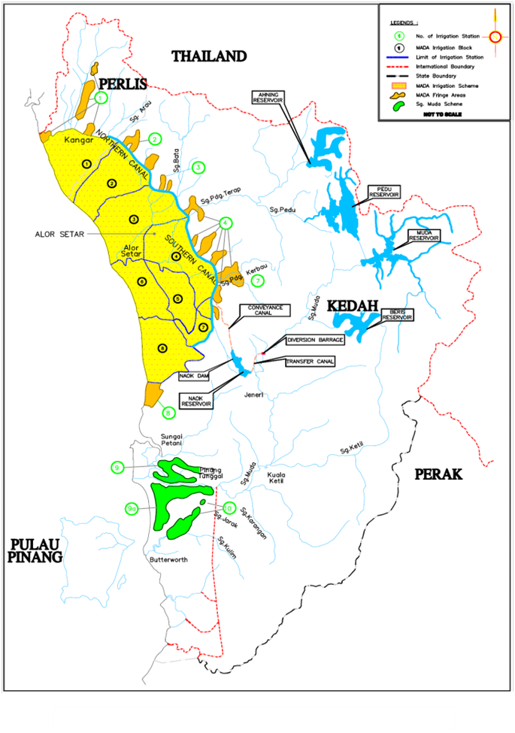

Myanmar
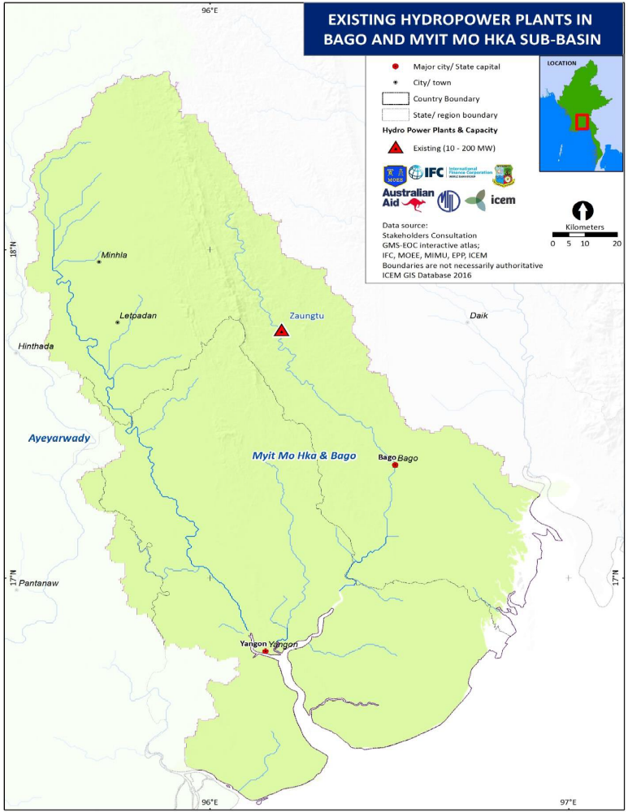

Philippines
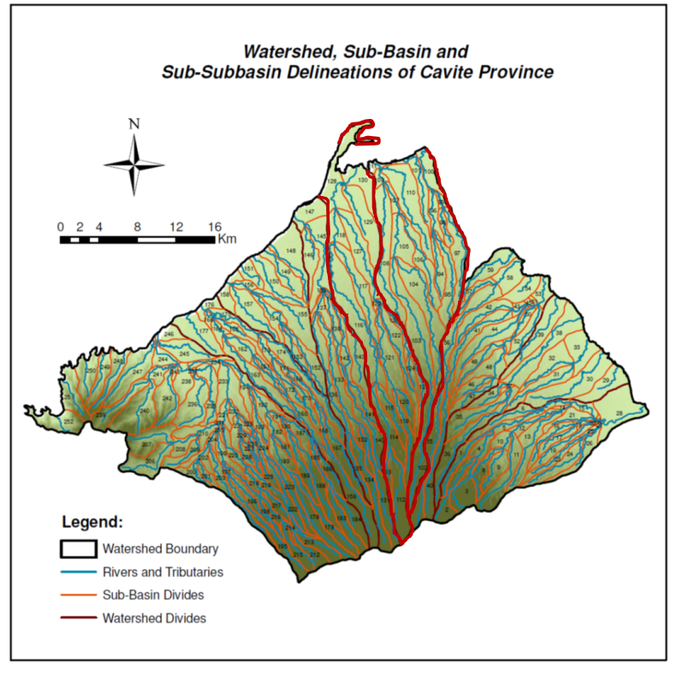

Vietnam
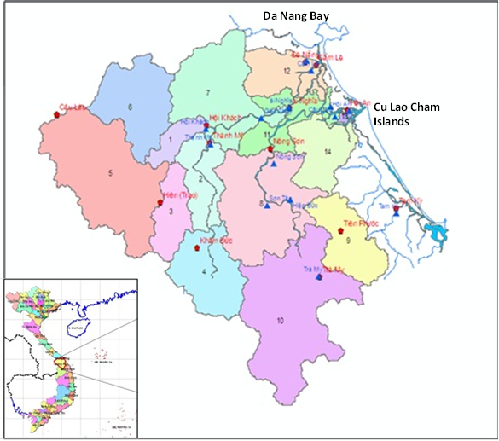

Project ID number remains the same as the assigned PIF number.
When completing Table A, refer to the excerpts on GEF 6 Results Frameworks for GETF, LDCF and SCCF.
Financing type can be either investment or technical assistance.
For GEF Project Financing up to $2 million, PMC could be up to 10% of the subtotal; above $2 million, PMC could be up to 5% of the subtotal. PMC should be charged proportionately to focal areas based on focal area financing amount in Table D below.
Update the applicable indicators provided at PIF stage. Progress in programming against these targets for the projects per the Corporate Results Framework in the GEF-6 Programming Directions, will be aggregated and reported during mid-term and at the conclusion of the replenishment period.
For questions A.1 –A.7 in Part II, if there are no changes since PIF , no need to respond, please enter “NA” after the respective question.
For biodiversity projects, in addition to explaining the project’s consistency with the biodiversity focal area strategy, objectives and programs, please also describe which Aichi Target(s) the project will directly contribute to achieving.
As per the GEF-6 Corporate Results Framework in the GEF Programming Directions and GEF-6 Gender Core Indicators in the Gender Equality Action Plan, provide information on these specific indicators on stakeholders (including civil society organization and indigenous peoples) and gender.
Same as footnote 8 above.
GEF policies encompass all managed trust funds, namely: GEFTF, LDCF, and SCCF
If at CEO Endorsement, the PPG activities have not been completed and there is a balance of unspent fund, Agencies can continue to undertake the activities up to one year of project start. No later than one year from start of project implementation, Agencies should report this table to the GEF Secretariat on the completion of PPG activities and the amount spent for the activities. Agencies should also report closing of PPG to Trustee in its Quarterly Report.

